**Devops:**

* Devops is a culture or practise of which fills gap between **development** team and **operations** team.
* Both the teams will work together in entire sdlc to ensure the quality of the product, ability of product to work in different environments.

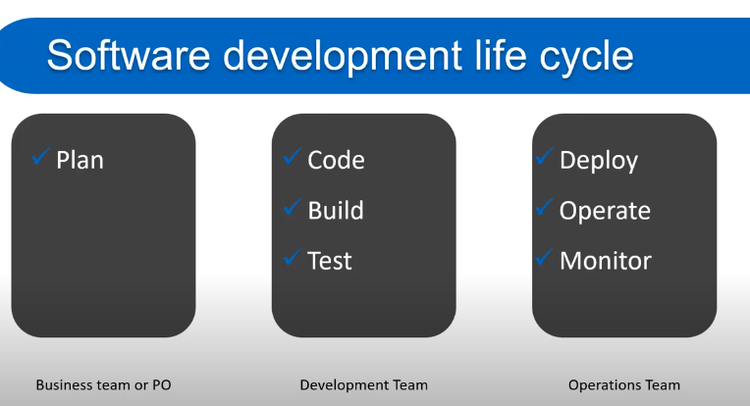

* DevOps is a set of practices that combines [software development](https://en.wikipedia.org/wiki/Software_development) (Dev) and [IT operations](https://en.wikipedia.org/wiki/IT_operations) (Ops). It aims to shorten the [systems development life cycle](https://en.wikipedia.org/wiki/Systems_development_life_cycle) and provide [continuous delivery](https://en.wikipedia.org/wiki/Continuous_delivery) with high [software quality](https://en.wikipedia.org/wiki/Software_quality).[[1]](https://en.wikipedia.org/wiki/DevOps#cite_note-Mala_2019_p._16-1)[[2]](https://en.wikipedia.org/wiki/DevOps#cite_note-loukides-2012-2) DevOps is complementary with [Agile software development](https://en.wikipedia.org/wiki/Agile_software_development); several DevOps aspects came from the Agile methodology.

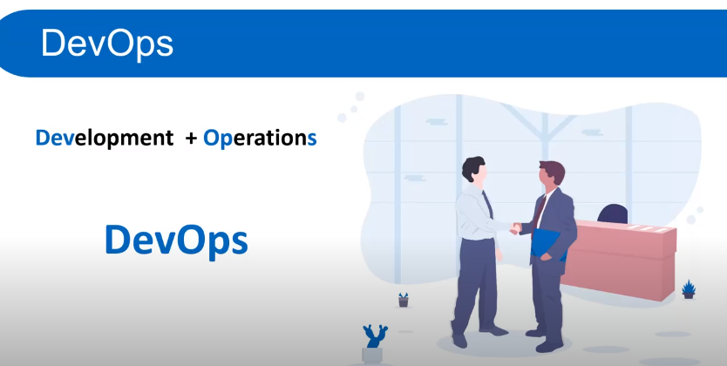

Azure DevOps

Azure DevOps provides developer service to support team to plan work, collaborate on code development, build and deploy the application.

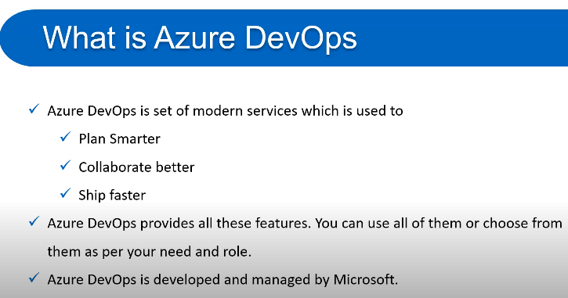

**For example** - We have a very simple application, and the only developer can make changes to that application. Once the changes are completed, the application will be submitted to testing, and once the testing has been done successfully, it will be published into production. However, if our application is a very complex application with multiple modules, and we have different developers working on the enhancement of various modules within the application. Then it will become very complex to merge changes done by different developers and also take it through testing and finally building the application and deploying the application into production. The more developer we have, the more complicated the process is going to be; precisely that complexity can be addressed using Azure DevOps. We can use Azure DevOps to deploy both infrastructure and code into Azure.

**Services of Azure DevOps**

Azure DevOps has a number of services that we can take advantage of to manage our code development, building the application, deploying the applications, and also making our developers collaborate.

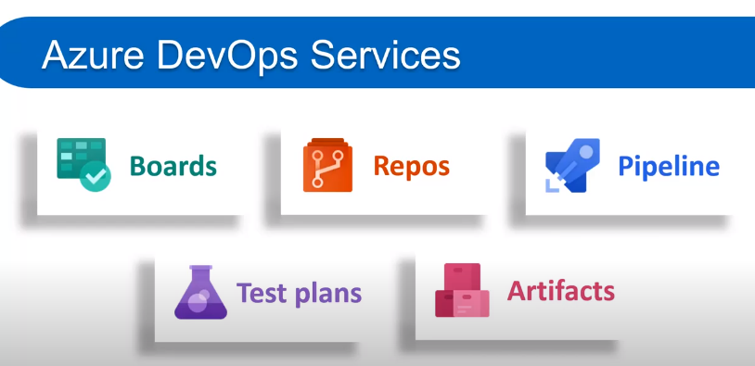

* **Azure Repository:** It is a set of version control tools that we can use to manage our code. We can either use Git repositories or team foundation version control for source control of our code. In Azure repositories, we can create multiple branches, and each branch represents a version of code, and we can provide access to a particular branch to a specific developer.
* **Azure pipeline:** It is a fully-featured continuous integration and continuous delivery service. It works with our preferred Git provider and can deploy to most major cloud services, which includes Azure services also. Using Azure pipelines, we can able to define a build pipeline to build our code and also a release pipeline to carry out release into a specific destination.
* **Boards:** It provides a rich set of capabilities, including native support for Scrum and Kanban, customizable dashboards, and integrated reporting. We can create different activities, track activities, and we can move activities between different buckets like Dun bucket, backlog bucket, in progress bucket, etc.
* **Test Plan:** It provides a browser-based test management solution with all capabilities required for planned manual testing, exploratory testing, etc.
* **Artifacts:** It is very important because most of our application will have some dependency on different packages, for example, NuGet package, npm, Maven package, etc. It also supports universal Packages, which can store any file or set of files.

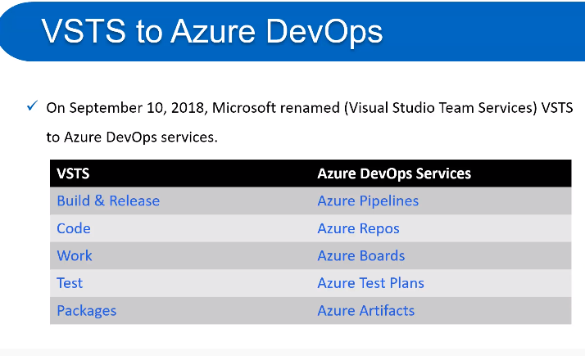

**Who should learn Devops**

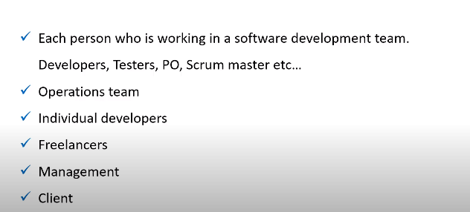

**Benefits of Devops**

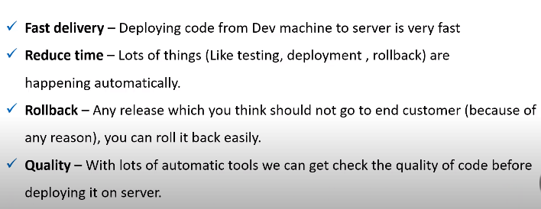

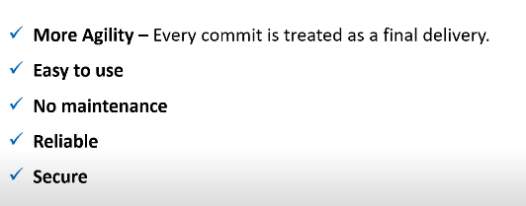

## Azure DevOps Portal

Azure DevOps portal is a centralized portal where we can manage all the Azure DevOps services. We need to create an account on the Azure portal to avail of all of the facilities. For the training purpose, we will take the free services. To create an Azure portal, organization, and project follow these steps carefully.

**Step 1:** Go to [https://Azure.microsoft.com/en-in/services/devops/](https://azure.microsoft.com/en-in/services/devops/) and click on **Start Free**.

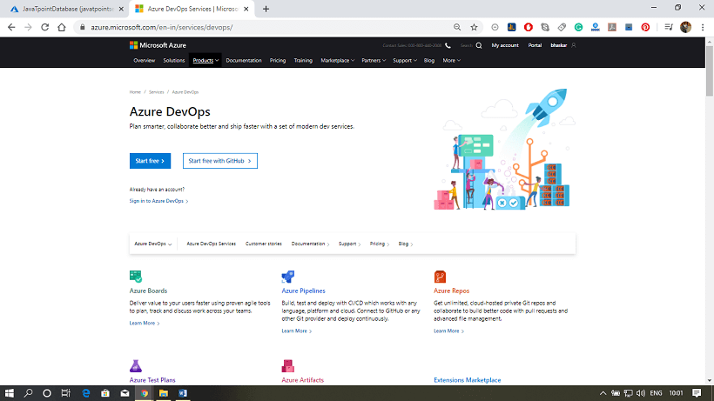

**Step 2:** After that, it will ask you to fill the details and region. Fill the details and click next.

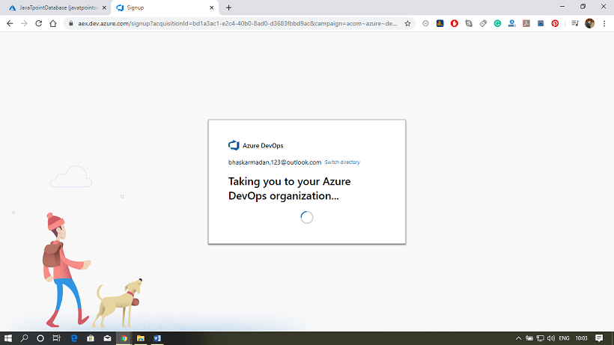

**Step 3:** Your Azure DevOps account has been created. And now, we will create an organization and create a project inside the organization.

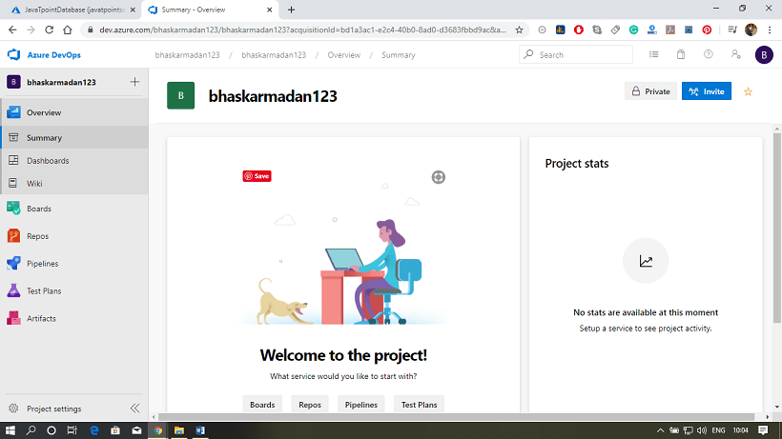

**Step 4:** Click on **New Organization**.

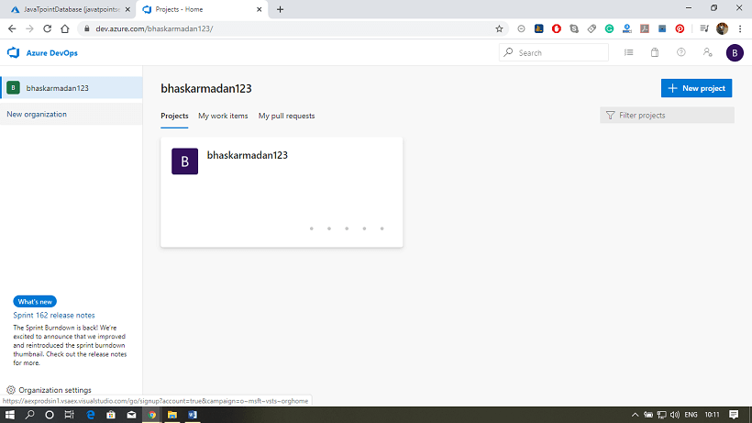

**Step 5:** Provide a name to your organization and select the location from where you want to get hosted your organization.

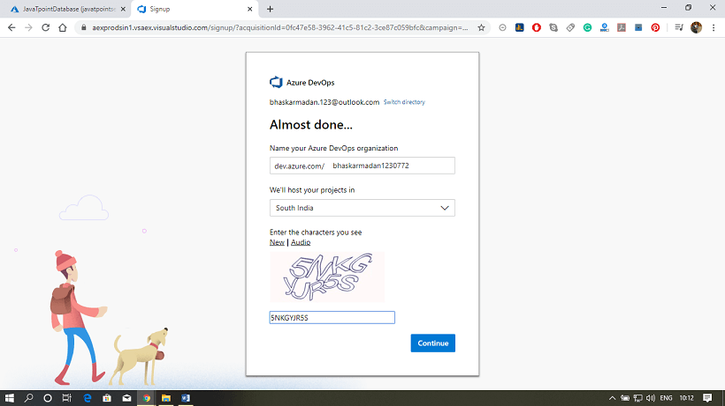

**Step 6:** Your organization has been created. Here you will see the Create a project page.

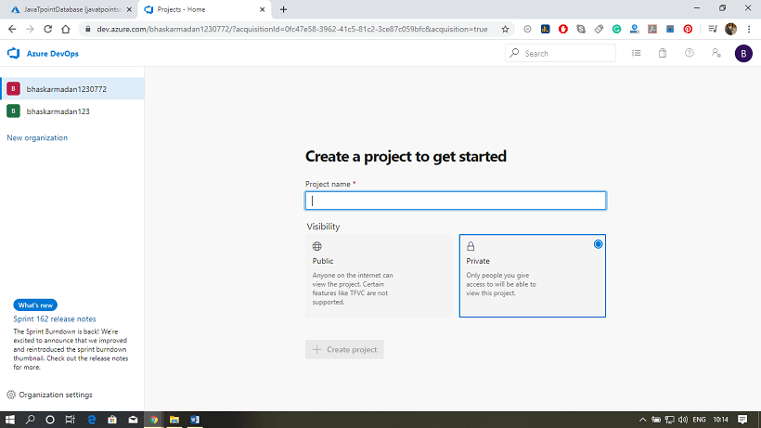

**Step 7:** Provide a name to your project. After that, click on **advanced,** then select the version control and work item process.

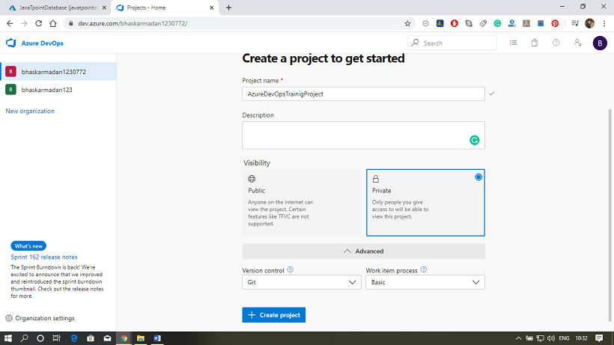

**Step 8:** Finally, click on the **create project** button. Your project has been created. Now, you can invite members to your project.

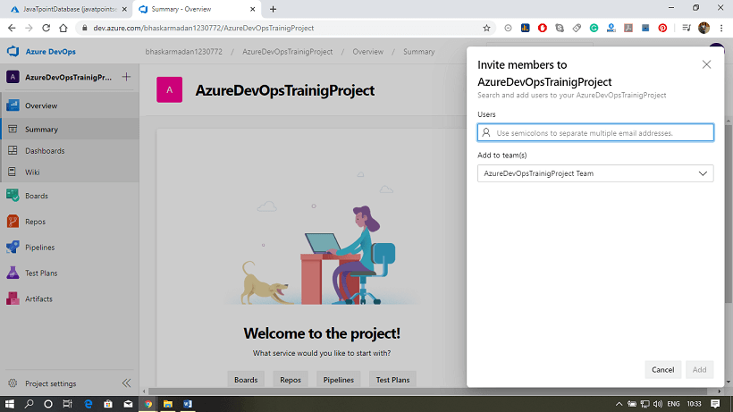

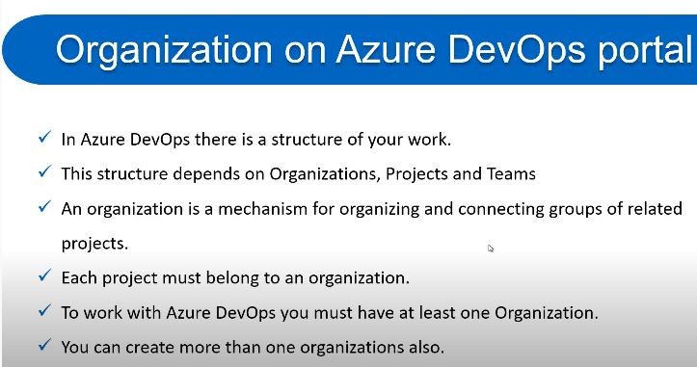

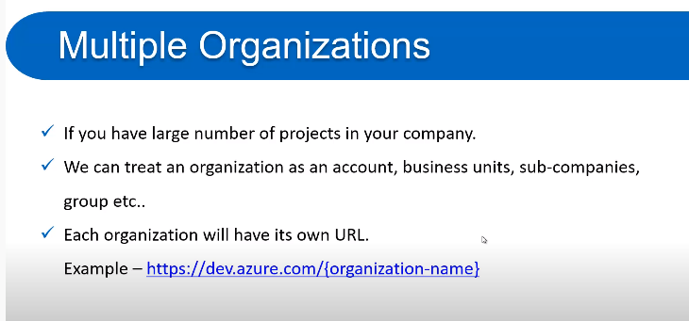

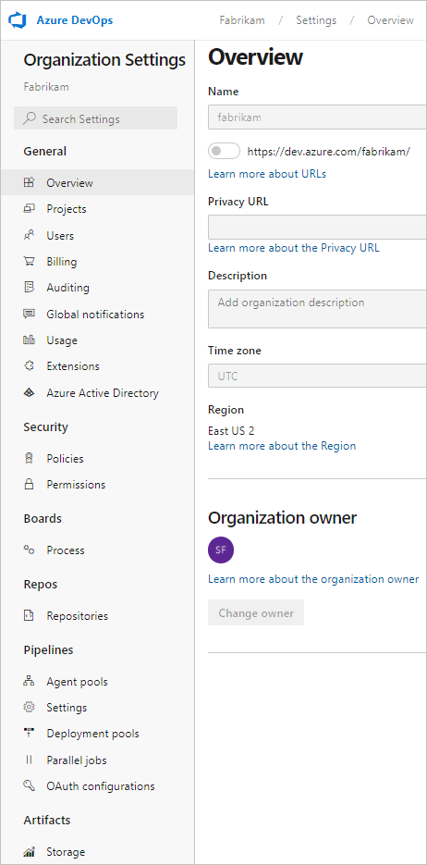

**Organization Settings:**

**Preview features**

Organization administrators can enable or disable organization-level or collection-level features that are in preview.

**Overview**

From the **Overview** page, you can manage the time zone, owner, region, and other settings that apply to all projects.

**Projects**

A project provides the fundamental resource for storing your code, managing your CI/CD operations, and planning and tracking work for your project. In general, minimize the number of projects you create, to keep things simple.

**Users**

For large organizations with a sizable number of users, we recommend that you [manage user access through Azure Active Directory](https://docs.microsoft.com/en-us/azure/devops/organizations/accounts/access-with-azure-ad?view=azure-devops). For a small number of users, you can manage user access by adding their Microsoft Service Account (MSA) email. From the account-level Users page, you can also [export the set of users and their access levels](https://docs.microsoft.com/en-us/azure/devops/organizations/security/export-users-audit-log?view=azure-devops).

**Billing**

All billing gets managed through Azure. For more information, see [Billing overview](https://docs.microsoft.com/en-us/azure/devops/organizations/billing/overview?view=azure-devops).

**Auditing**

The auditing page provides a simple view into the audit events recorded for your organization.

**Global notifications**

Many notifications are automatically defined when an organization is added. Notifications at the organization-level are managed in much the same way as they are at the [team level](https://docs.microsoft.com/en-us/azure/devops/notifications/manage-team-group-global-organization-notifications?view=azure-devops).

**Usage**

Certain rate limits are in place to ensure performance across the cloud service platform.

**Extensions**

An extension is an installable unit that contributes new capabilities to your projects. You can find extensions from within the [Visual Studio Marketplace](https://marketplace.visualstudio.com/azuredevops) in the Azure DevOps tab to support planning and tracking of work items, sprints, scrums, and so on; build and release flows; code testing and tracking; and collaboration among team members.

**Security: Policies**

Set policies to allow or disallow access by other applications or services to the organization.

**Security: Permissions**

For an overview of security concepts, see [About permissions, access, and security groups](https://docs.microsoft.com/en-us/azure/devops/organizations/security/about-permissions?view=azure-devops) and [About access levels](https://docs.microsoft.com/en-us/azure/devops/organizations/security/access-levels?view=azure-devops). For a list of collection-level permissions, see [Permissions and groups reference, Collection-level permissions](https://docs.microsoft.com/en-us/azure/devops/organizations/security/permissions?view=azure-devops#organization-level-permissions).

**Boards: Process**

Process customization applies to Azure Boards only. You can customize the Agile tools and work tracking artifacts. Create and customize an inherited process, and then update the project to use that process.

**Pipelines**  
**Build and release**

You manage resources that support CI/CD operations for all projects through the **Agent pools**, **Deployment pools**, and **Retention and limits** pages.

**Artifact storage**

Each organization gets Azure Artifacts for free, up until 2 GB of storage is reached.

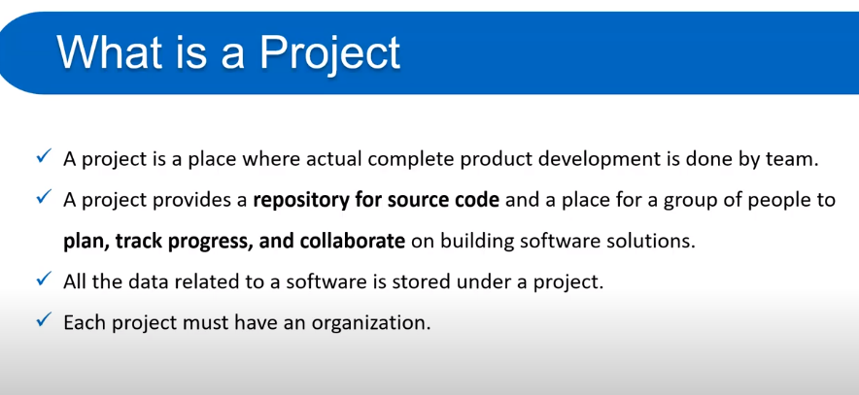

**Types of projects based on Visibility:**

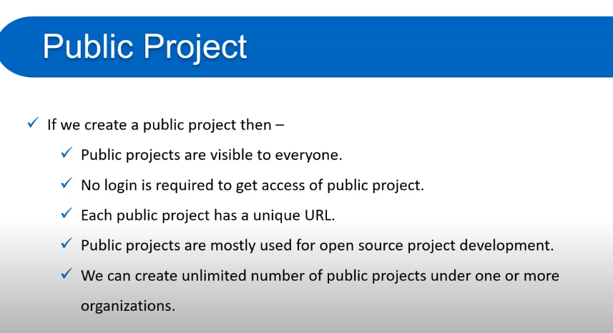

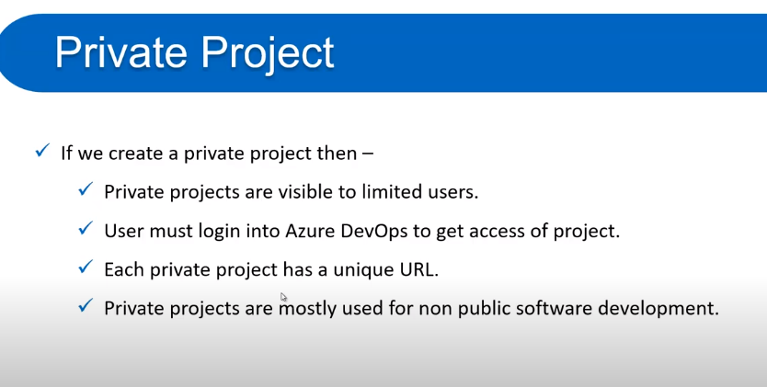

**Create a project**

1. Login to **Azure DevOps** portal to open the **Projects** page.
2. Choose the organization, and then select **New project**.

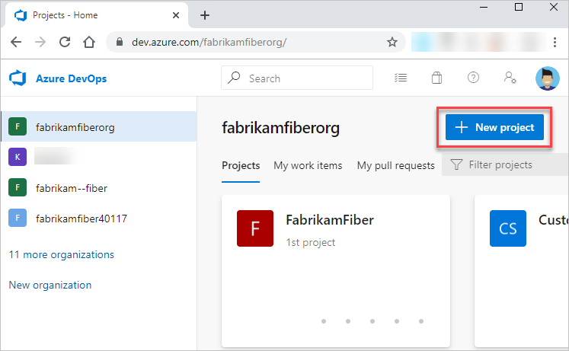

1. Enter information into the form provided. Provide a name for your project. Your project name can't contain special characters, such as / : \ ~ & % ; @ ' " ? < > | # $ * } { , + = [ ], can't begin with an underscore, can't begin or end with a period, and must be 64 or fewer characters. Enter an optional description. Choose the visibility, initial source control type, and work item process. For more information, see [Choosing the right version control for your project](https://docs.microsoft.com/en-us/azure/devops/repos/tfvc/comparison-git-tfvc?view=azure-devops) and [Choose a process](https://docs.microsoft.com/en-us/azure/devops/boards/work-items/guidance/choose-process?view=azure-devops).

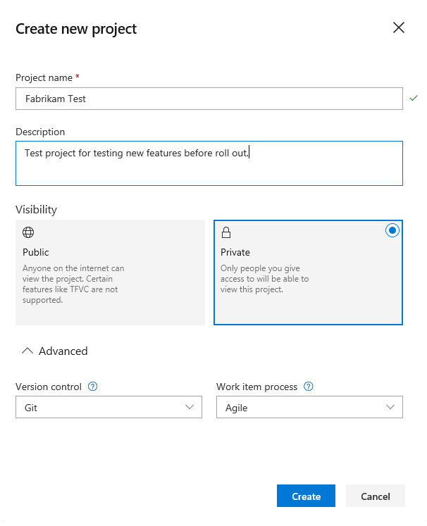

Select visibility of either public or private. When you choose public visibility, anyone on the internet can view your project. With private visibility, only people who you give access to can view your project. If the **Public** option isn't available, you need to change the policy.

**Connect to a project, collection, or server from your web browser.**

1. To view the projects defined for an organization, login to **Azure DevOps** portal open the **Projects** page.
2. Choose the organization to view the list of projects. The page lists the last two or three projects you connected to at the upper screen. Select any project to connect to that project.

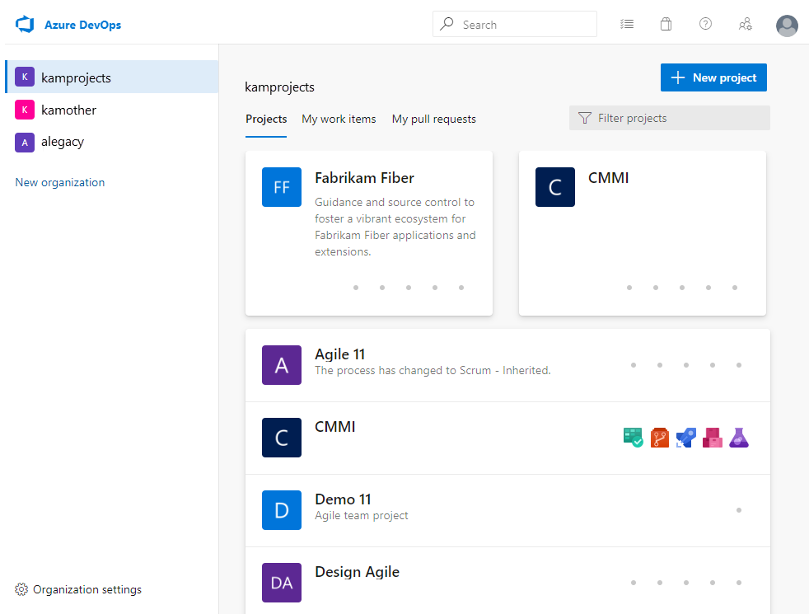

1. Or, choose **Organization settings** and then select **Projects** to list all projects.

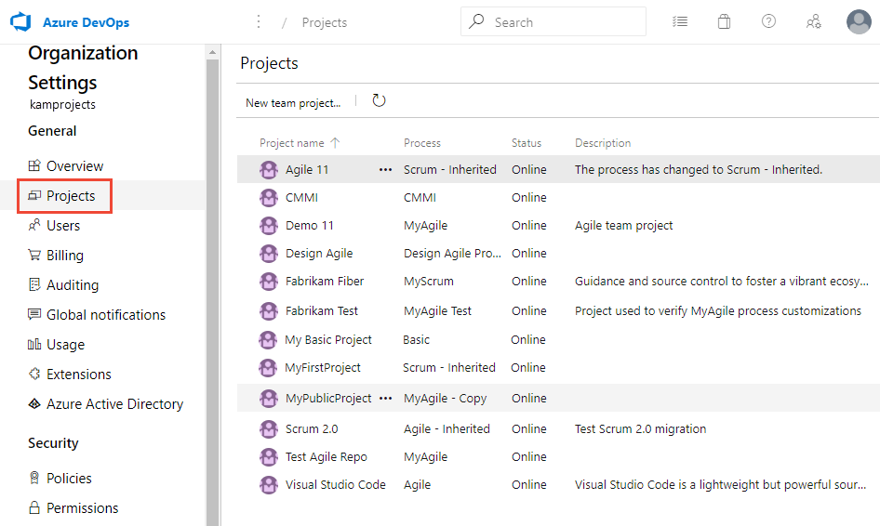

You can choose a project to open project settings for that project on this page.

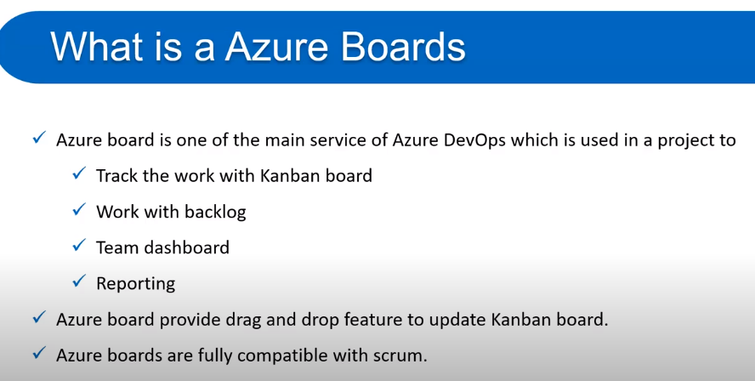

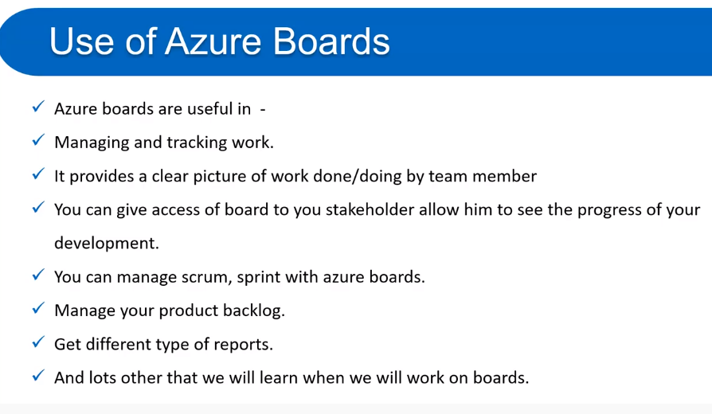

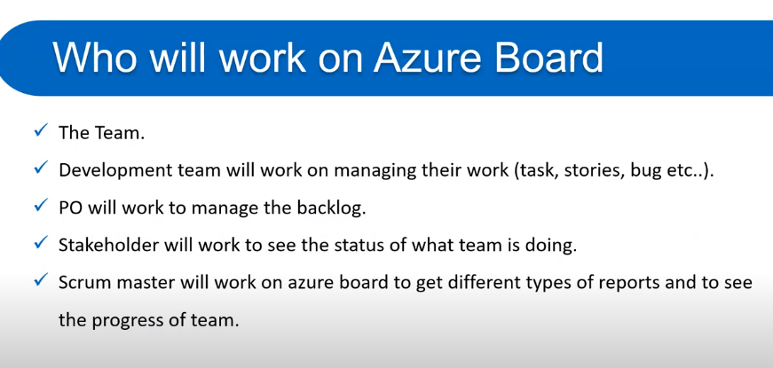

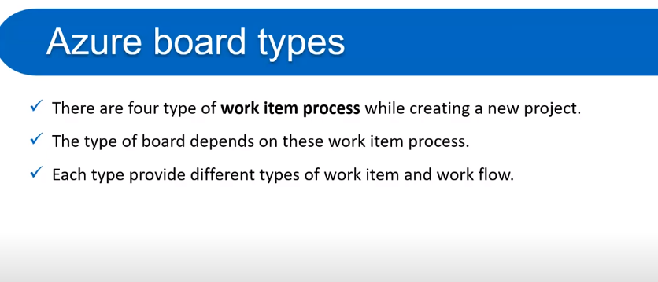

**Four types of azure boards process:**

1. Basic
2. Azile
3. CMM
4. Scrum

**Let’s start Azure boards with Basic process:**

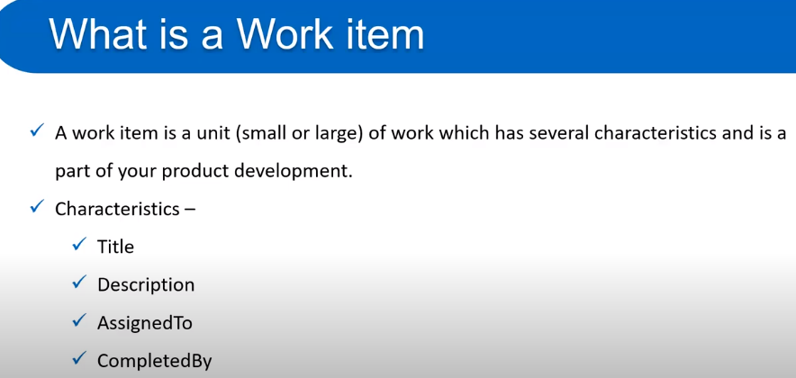

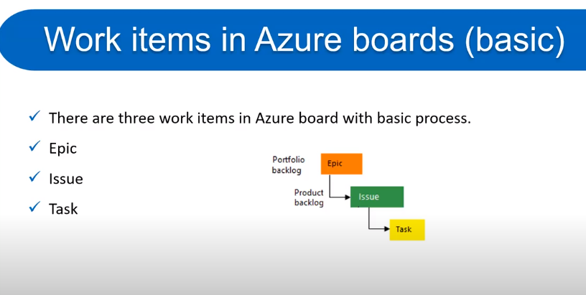

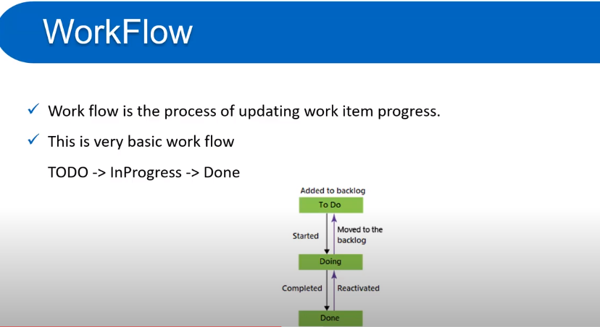

**What is Kanban boards:**

**Kanban board** turns your backlog into an interactive signboard, which provides a visual flow of work. As work progresses from idea to completion, you update the items on the **board**. Each column represents a work stage. Each card represents a backlog item, user story, or bug at that stage of work.

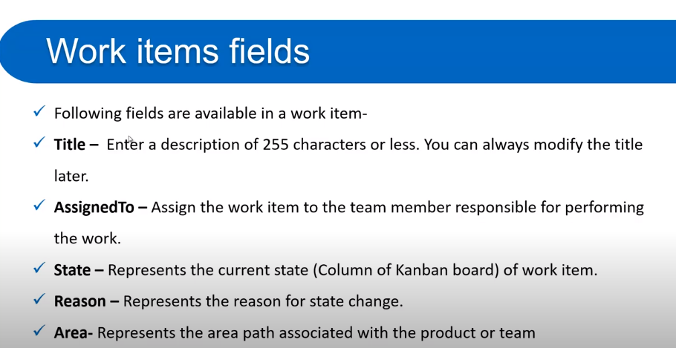

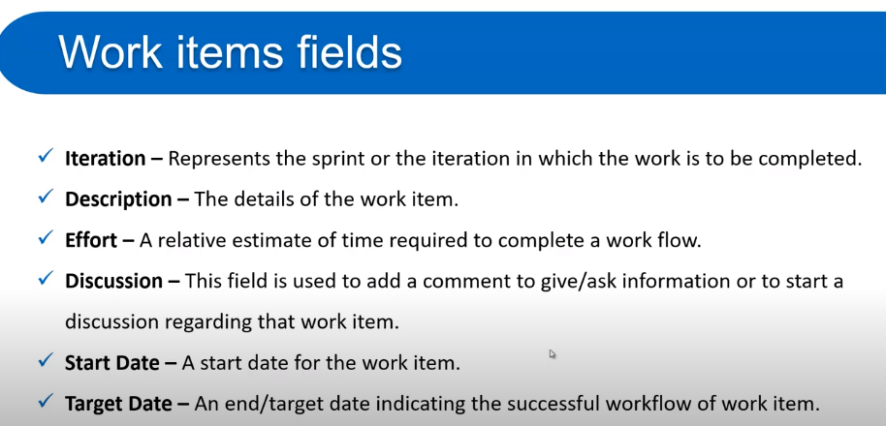

**Sample task view**

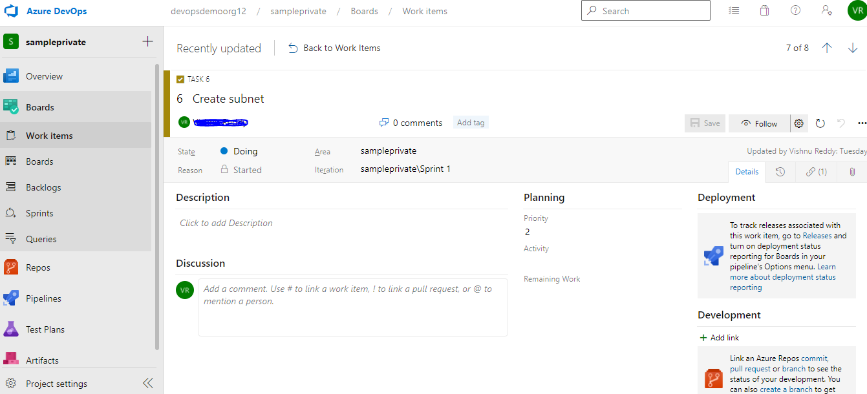

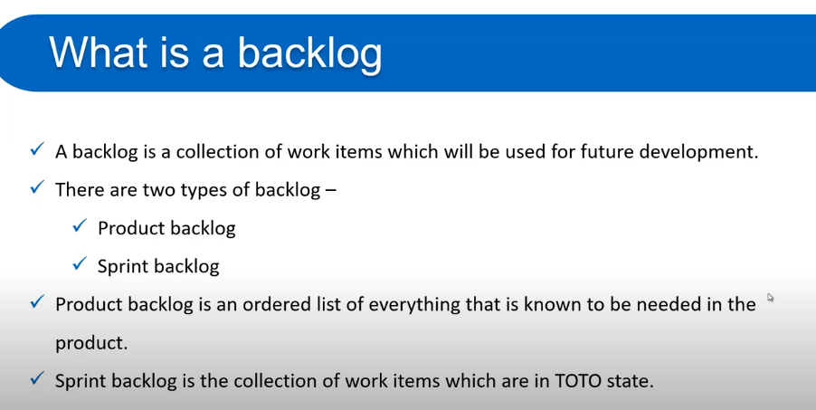

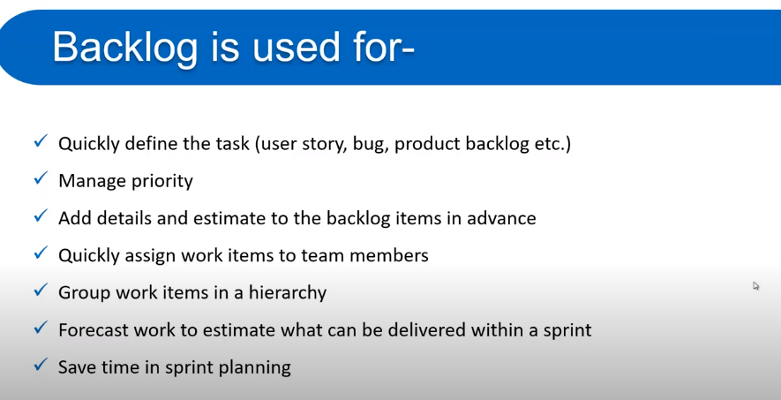

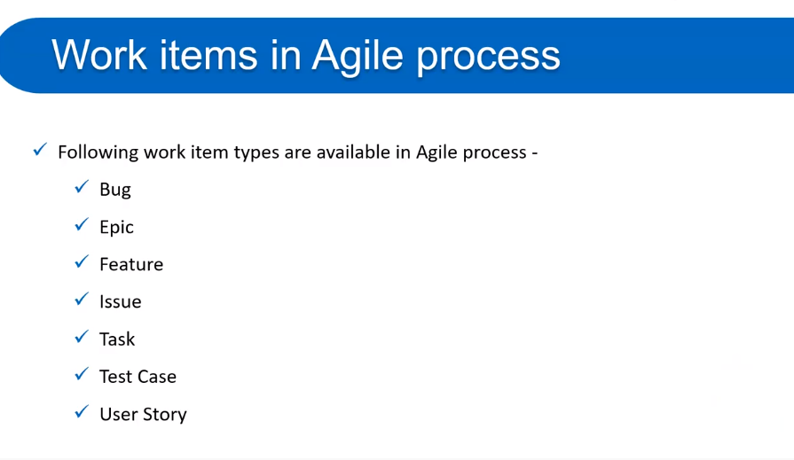

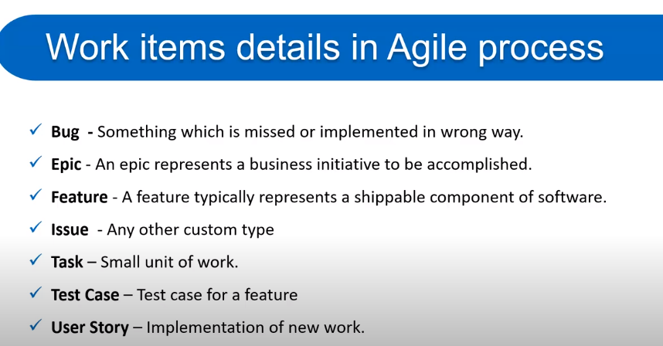

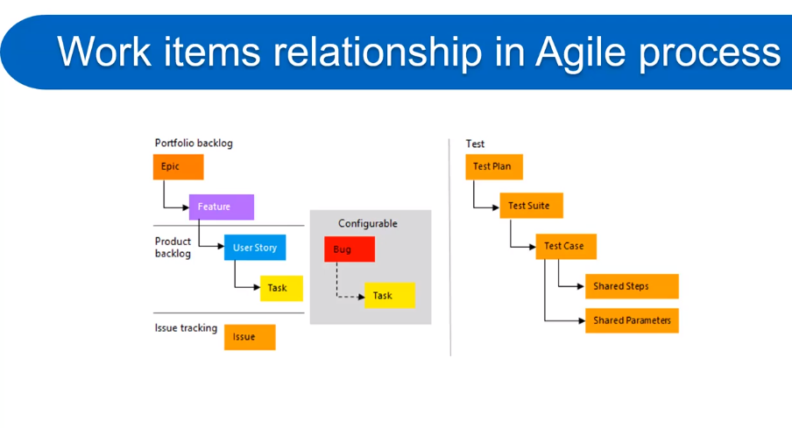

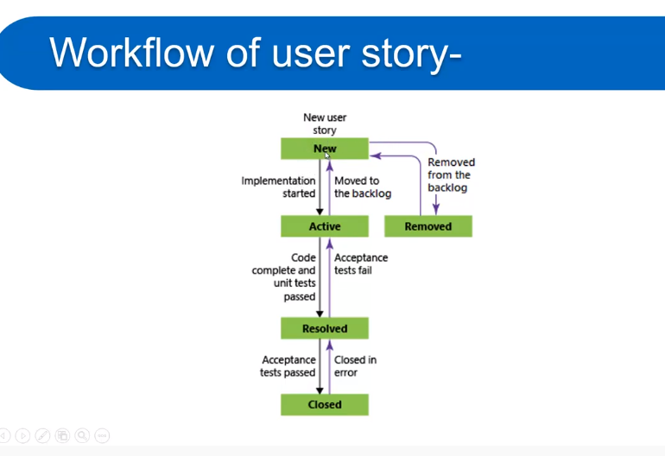

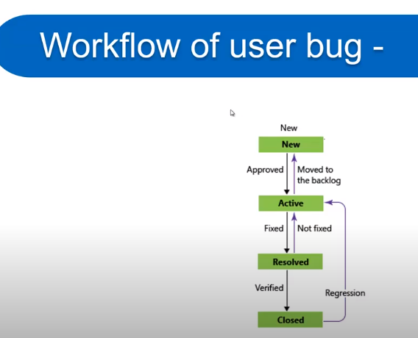

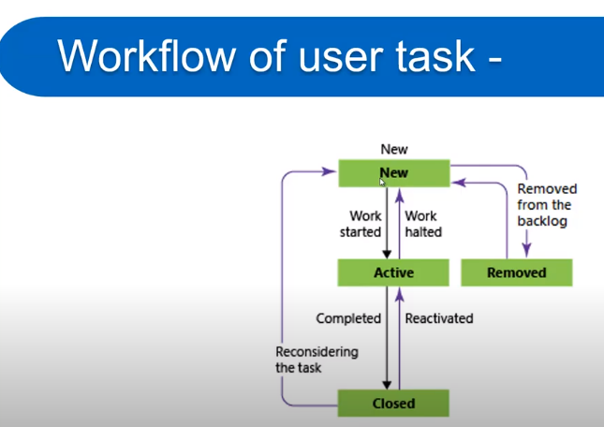

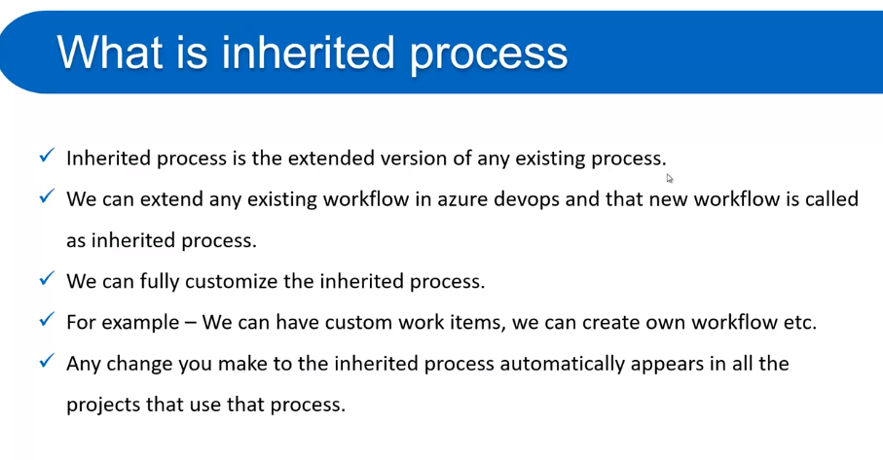

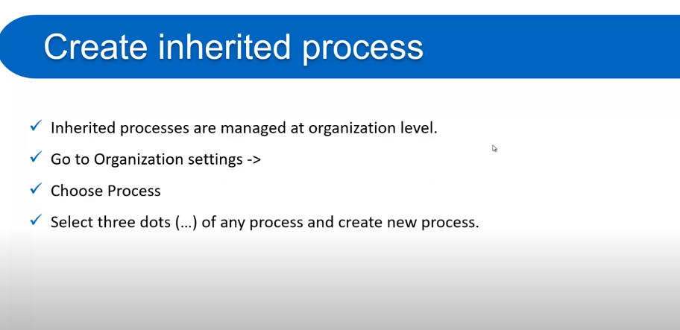

**Azure Repos**

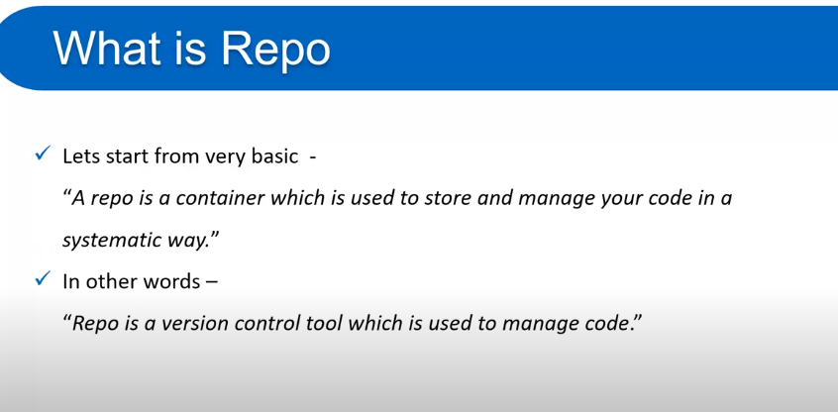

Azure Repository is a set of version control tools that we can use to manage our code. In case if we are entirely new to version control, then version control enables us to track changes we make in our code over time. There are so many software that is available in the market to enable version control on our code. We can use the version control system to keep track of each change done by each developer, safely merge them, test the changes, and publish the change into production.

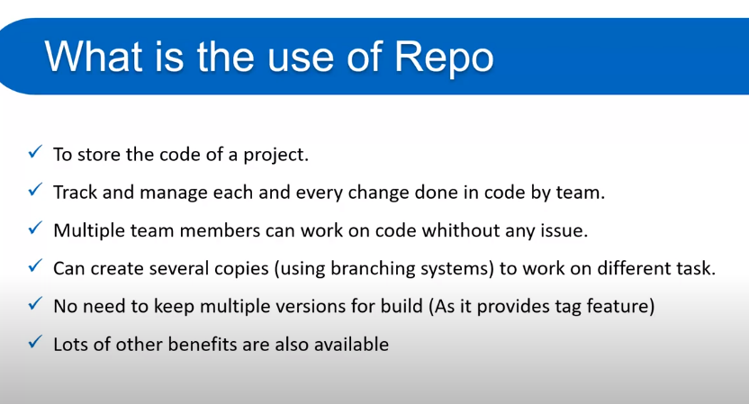

There are two types of version control in Azure Repos.

* **Git:** It is a distributed version control.
* **Team Foundation Version Control:** It is a centralized version control.

### **TFVC (centralized)**

Team Foundation Version Control (TFVC) is a centralized version control system. Typically, team members have only one version of each file on their dev machines. Historical data is maintained only on the server. Branches are path-based and created on the server.

TFVC has two [workflow models](https://docs.microsoft.com/en-us/azure/devops/repos/tfvc/decide-between-using-local-server-workspace?view=azure-devops):

* **Server workspaces** - Before making changes, team members publicly check out files. Most operations require developers to be connected to the server. This system facilitates locking workflows. Other systems that work this way include Visual Source Safe, Perforce, and CVS. With server workspaces, you can scale up to very large codebases with millions of files per branch and large binary files.
* **Local workspaces** - Each team member takes a copy of the latest version of the codebase with them and works offline as needed. Developers check in their changes and resolve conflicts as necessary. Another system that works this way is Subversion.

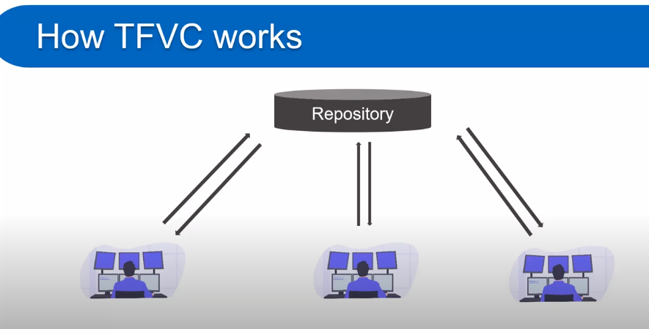

### **Git (distributed)**

Git is a distributed version control system. Each developer has a copy of the source repository on their dev machine. Developers can commit each set of changes on their dev machine and perform version control operations such as history and compare without a network connection. Branches are lightweight. When you need to switch contexts, you can create a private local branch. You can quickly switch from one branch to another to pivot among different variations of your codebase. Later, you can merge, publish, or dispose of the branch.

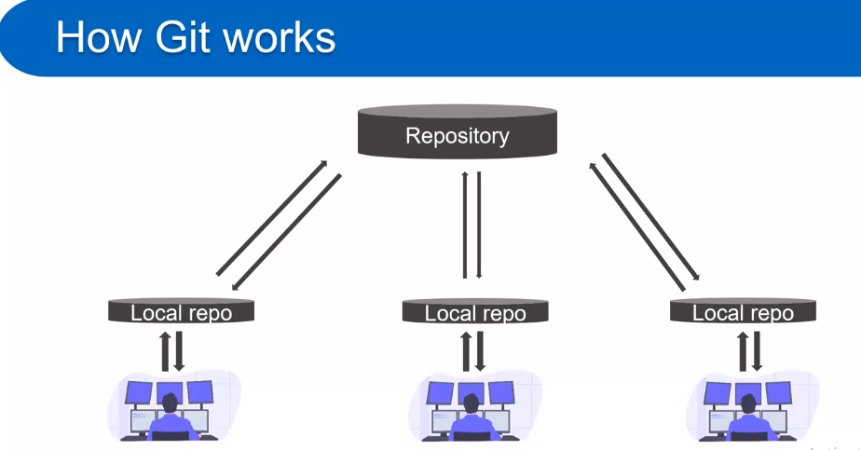

**Azure Repos Concepts**

## Branch

Branches are lightweight references that keep a history of commits and provide a way to isolate changes for a feature or a bug fix from your main branch and other work. Committing changes to a branch doesn't affect other branches. You can push and share branches with other people on your team without having to merge the changes into main.

Switching between branches is quick and easy. Git doesn't create multiple copies of your source code when you're working with branches - it uses the history information stored in commits to re-create the files in a branch when you start working on it.

## Branch policies

Branch policies are an important part of the Git workflow. You use them to help protect the important branches in your development, like main. Branch policies enable you to:

* Isolate work in progress from the completed work in your main branch.
* Guarantee that changes build before they get to main.
* Limit who can contribute to specific branches.
* Enforce who can create branches and the naming guidelines for the branches.
* Automatically include the right reviewers for every code change.
* Enforce best practices with required code reviewers.

## Clone

Create a complete local copy of an existing Git repo by cloning it. Cloning a repo downloads all [commits](https://docs.microsoft.com/en-us/azure/devops/repos/get-started/key-concepts-repos?view=azure-devops#commit) and [branches](https://docs.microsoft.com/en-us/azure/devops/repos/get-started/key-concepts-repos?view=azure-devops#branch) in the repo and sets up a named relationship with the existing repo that you cloned. Use this relationship to interact with the existing repo, [pushing](https://docs.microsoft.com/en-us/azure/devops/repos/get-started/key-concepts-repos?view=azure-devops#push) and [pulling](https://docs.microsoft.com/en-us/azure/devops/repos/get-started/key-concepts-repos?view=azure-devops#pull) changes to share code with your team.

## Commit

A commit is a group of changes saved to your local repository. You can share these changes to the remote repository by [pushing](https://docs.microsoft.com/en-us/azure/devops/repos/get-started/key-concepts-repos?view=azure-devops#push).

## Fork

A fork is a complete copy of a repository, including all files, commits, and (optionally) branches. The new fork acts as if someone cloned the original repository and then pushed to a new, empty repository. After a fork has been created, new files, folders, and branches are not shared between the repositories unless a pull request carries them along. When you're ready to share those changes, it's easy to use pull requests to push the changes back to the original repository.

## Git

Git is the most commonly used version control system today and is quickly becoming the standard for version control. Git is a distributed version control system, so your local copy of code is a complete version control repository. These fully functional local repositories make it is easy to work offline or remotely. You commit your work locally, and then sync your copy of the repository with the copy on the server.

Git in Azure Repos is standard Git. You can use the clients and tools of your choice, such as Git for Windows, Mac, partners' Git services, and tools such as Visual Studio and Visual Studio Code.

## Git workflow

Version control has a general workflow that most developers use when writing code and sharing it with the team. These steps are:

1. Get a local copy of code if they don't have one yet.
2. Make changes to code to fix bugs or add new features.
3. When the code is ready, make it available for your team to review.
4. After the code is reviewed, merge it into the team's shared codebase.

Git has a version of this workflow that uses terminology and commands such as repositories, branches, commits, and pull requests. These terms might sound familiar if you've used a version control system like Team Foundation Version Control (TFVC) or Subversion, but they behave differently in Git.

1. [Create a branch](https://docs.microsoft.com/en-us/azure/devops/repos/get-started/key-concepts-repos?view=azure-devops#branch) for the changes you plan to make and give it a name, such as users/jamal/fix-bug-3214 or features/cool-feature.
2. [Commit changes](https://docs.microsoft.com/en-us/azure/devops/repos/get-started/key-concepts-repos?view=azure-devops#commit) to your branch. People often have multiple commits for a bug fix or feature.
3. [Push your branch](https://docs.microsoft.com/en-us/azure/devops/repos/get-started/key-concepts-repos?view=azure-devops#push) to the remote repository.
4. [Create a pull request](https://docs.microsoft.com/en-us/azure/devops/repos/get-started/key-concepts-repos?view=azure-devops#pull-request) so other people can review your changes. To incorporate feedback, you might need to make more commits and push more changes. When the code is ready, complete the pull request and merge your code into the target branch, such as main.

Use this workflow if you're new to Git. As your team gets more experienced and confident with Git, extend it to suit your team's needs.

**Azure Pipelines:**

Azure Pipelines supports continuous integration (CI) and continuous delivery (CD) to constantly and consistently test and build your code and ship it to any target. You accomplish this by defining a pipeline. You define pipelines using the YAML syntax or through the user interface (Classic).

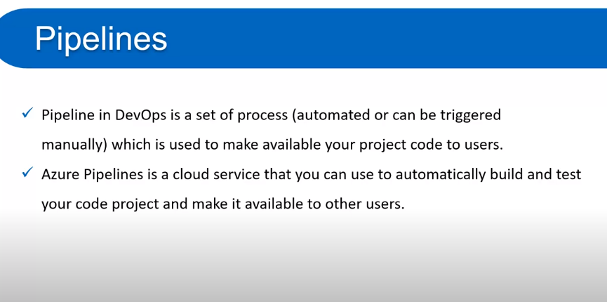

**Automate tests, builds, and delivery**

Continuous integration automates tests and builds for your project. CI helps to catch bugs or issues early in the development cycle, when they're easier and faster to fix. Items known as artifacts are produced from CI systems. They're used by the continuous delivery release pipelines to drive automatic deployments.

| **Continuous integration (CI)** | **Continuous delivery (CD)** |
| --- | --- |
| - Increase code coverage - Build faster by splitting test and build runs - Automatically ensure you don't ship broken code - Run tests continually. | - Automatically deploy code to production - Ensure deployment targets have latest code - Use tested code from CI process. |

Continuous delivery automatically deploys and tests code in multiple stages to help drive quality. Continuous integration systems produce deployable artifacts, which include infrastructure and apps. Automated release pipelines consume these artifacts to release new versions and fixes to the target of your choice.

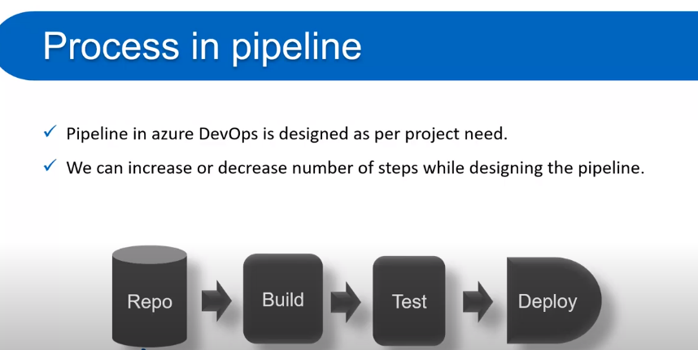

## Azure DevOps Pipeline concepts

## Agent

When your build or deployment runs, the system begins one or more jobs. An agent is computing infrastructure with installed agent software that runs one job at a time. For example, your job could run on a Microsoft-hosted Ubuntu agent.

## Approvals

[Approvals](https://docs.microsoft.com/en-us/azure/devops/pipelines/process/approvals?view=azure-devops) define a set of validations required before a deployment runs. Manual approval is a common check performed to control deployments to production environments. When checks are configured on an environment, pipelines will stop before starting a stage that deploys to the environment until all the checks are completed successfully.

## Artifact

An artifact is a collection of files or packages published by a run. Artifacts are made available to subsequent tasks, such as distribution or deployment. For more information, see [Artifacts in Azure Pipelines](https://docs.microsoft.com/en-us/azure/devops/pipelines/artifacts/artifacts-overview?view=azure-devops).

## Continuous delivery

Continuous delivery (CD) is a process by which code is built, tested, and deployed to one or more test and production stages. Deploying and testing in multiple stages helps drive quality. Continuous integration systems produce deployable artifacts, which include infrastructure and apps. Automated release pipelines consume these artifacts to release new versions and fixes to existing systems. Monitoring and alerting systems run constantly to drive visibility into the entire CD process. This process ensures that errors are caught often and early.

## Continuous integration

Continuous integration (CI) is the practice used by development teams to simplify the testing and building of code. CI helps to catch bugs or problems early in the development cycle, which makes them easier and faster to fix. Automated tests and builds are run as part of the CI process. The process can run on a set schedule, whenever code is pushed, or both. Items known as artifacts are produced from CI systems. They're used by the continuous delivery release pipelines to drive automatic deployments.

## Deployment group

A deployment group is a set of deployment target machines that have agents installed. A deployment group is just another grouping of agents, like an [agent pool](https://docs.microsoft.com/en-us/azure/devops/pipelines/agents/pools-queues?view=azure-devops). You can set the deployment targets in a pipeline for a job using a deployment group. Learn more about provisioning agents for [deployment groups](https://docs.microsoft.com/en-us/azure/devops/pipelines/release/deployment-groups/howto-provision-deployment-group-agents?view=azure-devops).

## Environment

An [environment](https://docs.microsoft.com/en-us/azure/devops/pipelines/process/environments?view=azure-devops) is a collection of resources, where you deploy your application. It can contain one or more virtual machines, containers, web apps, or any service that's used to host the application being developed. A pipeline might deploy the app to one or more environments after build is completed and tests are run.

## Job

A stage contains one or more [jobs](https://docs.microsoft.com/en-us/azure/devops/pipelines/process/phases?view=azure-devops). Each job runs on an agent. A job represents an execution boundary of a set of steps. All of the steps run together on the same agent. Jobs are most useful when you want to run a series of steps in different environments. For example, you might want to build two configurations - x86 and x64. In this case, you have one stage and two jobs. One job would be for x86 and the other job would be for x64.

## Pipeline

A pipeline defines the continuous integration and deployment process for your app. It's made up of one or more stages. It can be thought of as a workflow that defines how your test, build, and deployment steps are run.

## Run

A run represents one execution of a pipeline. It collects the logs associated with running the steps and the results of running tests. During a run, Azure Pipelines will first process the pipeline and then send the run to one or more agents. Each agent will run jobs. Learn more about the [pipeline run sequence](https://docs.microsoft.com/en-us/azure/devops/pipelines/process/runs?view=azure-devops).

## Script

A script runs code as a step in your pipeline using command line, PowerShell, or Bash. You can write [cross-platform scripts](https://docs.microsoft.com/en-us/azure/devops/pipelines/scripts/cross-platform-scripting?view=azure-devops) for macOS, Linux, and Windows. Unlike a [task](https://docs.microsoft.com/en-us/azure/devops/pipelines/get-started/key-pipelines-concepts?view=azure-devops#task), a script is custom code that is specific to your pipeline.

## Stage

A [stage](https://docs.microsoft.com/en-us/azure/devops/pipelines/process/stages?view=azure-devops) is a logical boundary in the pipeline. It can be used to mark separation of concerns (for example, Build, QA, and production). Each stage contains one or more jobs. When you define multiple stages in a pipeline, by default, they run one after the other. You can specify the conditions for when a stage runs. When you are thinking about whether you need a stage, ask yourself:

* Do separate groups manage different parts of this pipeline? For example, you could have a test manager that manages the jobs that relate to testing and a different manager that manages jobs related to production deployment. In this case, it makes sense to have separate stages for testing and production.
* Is there a set of [approvals](https://docs.microsoft.com/en-us/azure/devops/pipelines/process/approvals?view=azure-devops) that are connected to a specific job or set of jobs? If so, you can use stages to break your jobs into logical groups that require approvals.
* Are there jobs that need to run a long time? If you have part of your pipeline that will have an extended run time, it makes sense to divide them into their own stage.

## Step

A step is the smallest building block of a pipeline. For example, a pipeline might consist of build and test steps. A step can either be a script or a task. A task is simply a pre-created script offered as a convenience to you. To view the available tasks, see the [Build and release tasks](https://docs.microsoft.com/en-us/azure/devops/pipelines/tasks/?view=azure-devops) reference. For information on creating custom tasks, see [Create a custom task](https://docs.microsoft.com/en-us/azure/devops/extend/develop/add-build-task?view=azure-devops).

## Task

A [task](https://docs.microsoft.com/en-us/azure/devops/pipelines/process/tasks?view=azure-devops) is the building block for defining automation in a pipeline. A task is packaged script or procedure that has been abstracted with a set of inputs.

## Trigger

A trigger is something that's set up to tell the pipeline when to run. You can configure a pipeline to run upon a push to a repository, at scheduled times, or upon the completion of another build. All of these actions are known as triggers. For more information, see [build triggers](https://docs.microsoft.com/en-us/azure/devops/pipelines/build/triggers?view=azure-devops) and [release triggers](https://docs.microsoft.com/en-us/azure/devops/pipelines/release/triggers?view=azure-devops).

# Setting up CI/CD pipeline to deploy a .net core application to an IIS Server through Azure Devops

What you will learn

* Add the project source to azure devops source control via git.
* Add Azure Virtual Machine.
* Setup IIS Manager in azure vm — windows server 2016
* Setup build pipeline.
* Setup deployment group.
* Setup release pipeline.
* Provision agents for deployment.

Prerequisites to begin:

* .Net 3.0 SDK installed, install by clicking below link
* <https://dotnet.microsoft.com/download/dotnet/3.1>

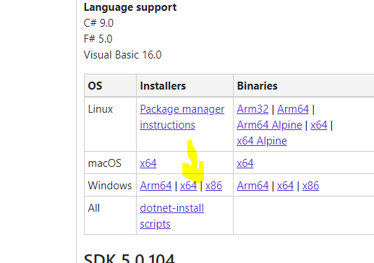

#### **Step 1:** **Creating a repository in azure devops**

Login to azure devops and create a project by selecting git as the source control. Then selecting the menu item repos, will show you the repository to be initialized. If you are using an existing project with repositories, then simply go to repos and add a new repository. Or else, if you are already having a git repository in somewhere else other than azure devops you can import it by selecting the import option. Once you have finished creating a new repository, you are able to clone the repository as preferred, using HTTPS/SSH. (SSH Recommended)

[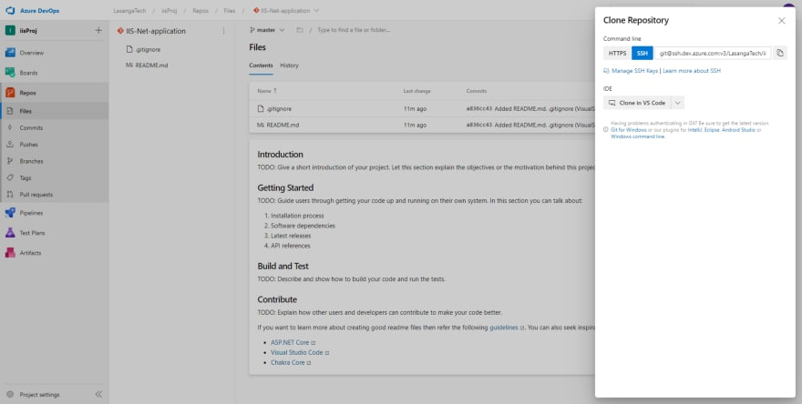](https://res.cloudinary.com/practicaldev/image/fetch/s--RCU0Bjzc--/c_limit,f_auto,fl_progressive,q_auto,w_880/https:/cdn-images-1.medium.com/max/880/1*YiI2fpeDxqtFx2RZj5H0Qw.png)

**clone repository**

Clone the repository into your local file folder by executing the following command.

**git clone {clone-url-copied}**

Change directory to the cloned folder and create the .net core web application. If you are familiar with the dotnet commands it will be easy to use the following steps to create the application. Else you can open up visual studio and create the application.

**dotnet --help //if needed**

**dotnet new sln -n {solution-name}**

**dotnet new webapp -n {project-name} //3.0 .net core web app**

**dotnet sln add {project-name}** //only if the project is in same directory. else provide the path

**dotnet build**

**git add .**

**git commit -m "commit message"**

**git push**

The project source will be added into the repository by now as mentioned in the figure below.

[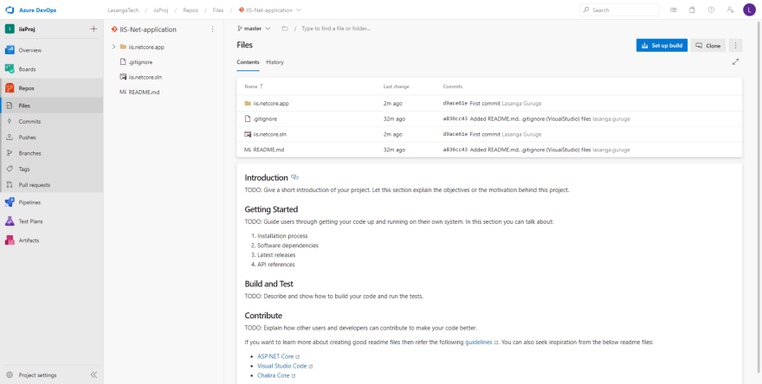](https://res.cloudinary.com/practicaldev/image/fetch/s--F2AdXLiK--/c_limit,f_auto,fl_progressive,q_auto,w_880/https:/cdn-images-1.medium.com/max/880/1*7R86DAUpwz6bQq5gWExYGw.png)

#### **Step 2: Setup the build pipeline**

Now everything is ready to setup the build pipeline for this application. Two ways to setup the build pipeline. As shown in the above figure we can click on setup build, which will provide us most relevant build templates per the source and create the pipeline with YAML. Else we can go from the scratch by selecting pipelines → new pipeline → use the classic editor. Going forward, user will be asked to select the version control, project, repository and the branch to trigger the build. Providing the required data will take you to the editor to select a template.  
  
Select the ASP.NET Core template and apply.

[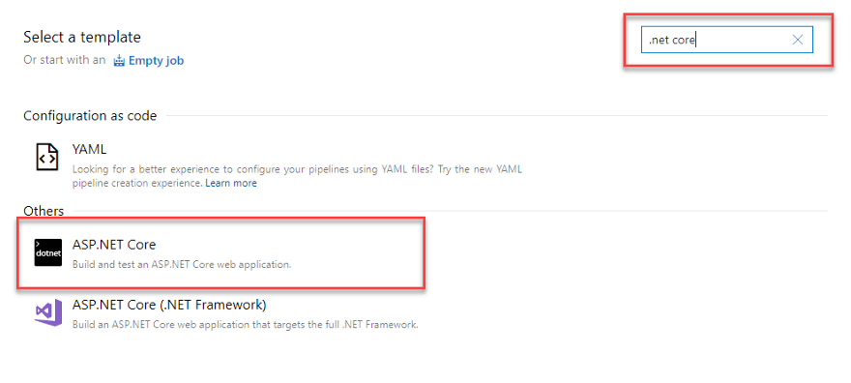](https://res.cloudinary.com/practicaldev/image/fetch/s--2zMWc3QF--/c_limit,f_auto,fl_progressive,q_auto,w_880/https:/cdn-images-1.medium.com/max/880/1*84nfirxi-kxhLq3XEJx_Og.png)

You can give a preferred name to the build pipeline by editing the first highlighted area on the top. The task highlighted (Use sdk task) would not be included in this template. It is added manually by clicking on the + icon on the top to ensure that we are using the correct sdk version which the project is using. In a scenario where, application is using .net core version 3.1.100 we will have to change the version into 3.1.100. Otherwise the build will fail. Anyhow, in our scenario we are using 3.0.100

Other tasks can be left with the default values since this is a simple .net core web applications.

[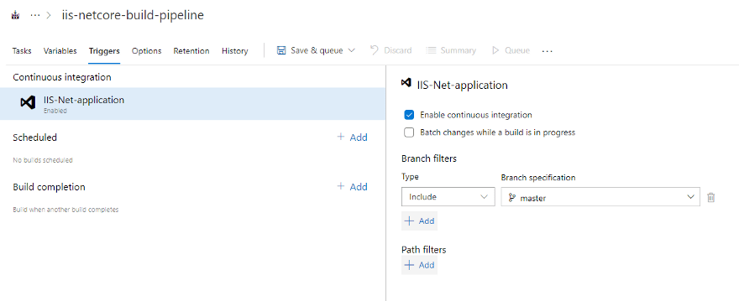](https://res.cloudinary.com/practicaldev/image/fetch/s--UAYVf0jz--/c_limit,f_auto,fl_progressive,q_auto,w_880/https:/cdn-images-1.medium.com/max/880/1*3L1OpnDImLlOb104YvkU0w.png)

Navigate to the Triggers section and check the Enable continuous integration checkbox. This means that, when ever the master branch gets a commit by a developer, this build pipeline will trigger. Now we are ready to run our first build. Click on the Save & queue drop-down and select save and queue. This will prompt you asking for some parameters. Keep the default values for now and click on save and run.

By now you have triggered the build pipeline manually. You can observe the pipeline by clicking on the ongoing job. The logs of each tasks can be seen after clicking on the ongoing job as shown below.

[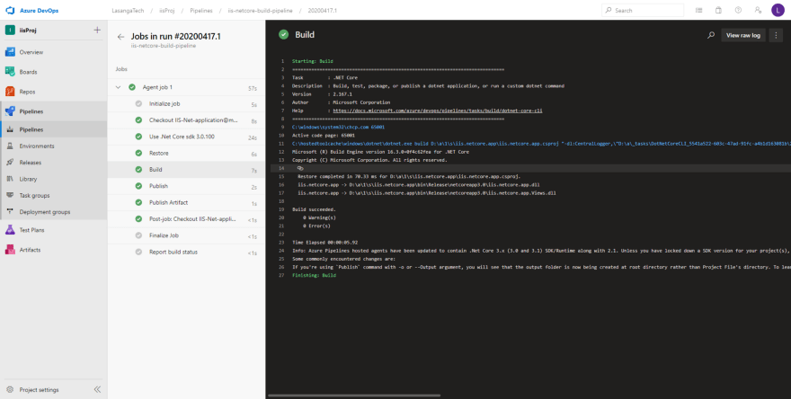](https://res.cloudinary.com/practicaldev/image/fetch/s--1Ie70Bpm--/c_limit,f_auto,fl_progressive,q_auto,w_880/https:/cdn-images-1.medium.com/max/880/1*iyjFpK2ylqzLXpXctKr8OQ.png)

We are done with the build pipeline now. Let’s move on to step 3

#### **Step 3: Creating a Azure Virtual machine**

Sign in to your azure account and login to the azure portal. Create a new resource group. In the search by search for, “virtual machines”. If you don’t have an existing virtual machine please create a new by clicking on add or create virtual machine. Following figure will provide support in creating the vm.

[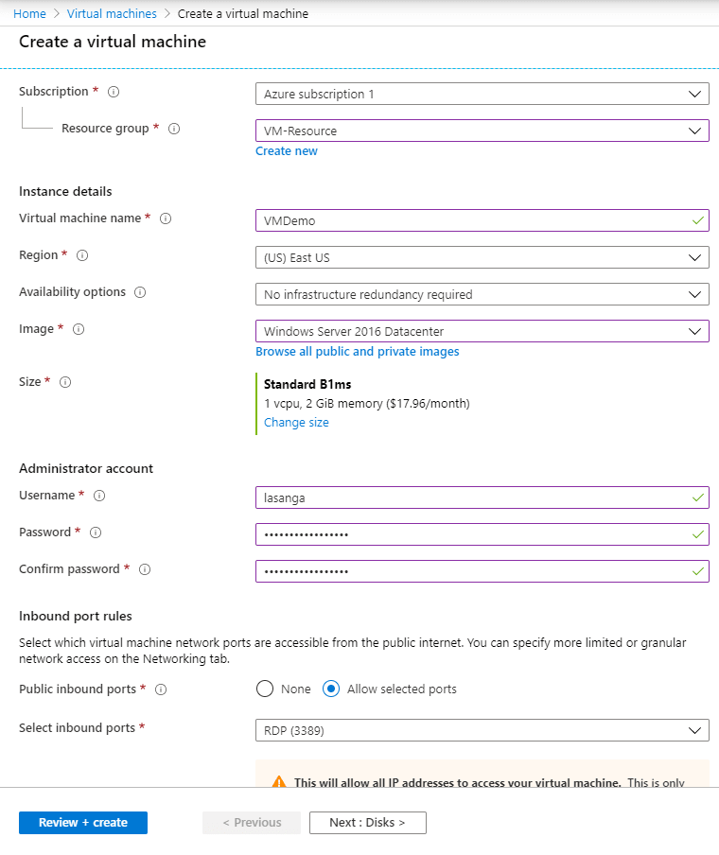](https://res.cloudinary.com/practicaldev/image/fetch/s--a4GxTtEM--/c_limit,f_auto,fl_progressive,q_auto,w_880/https:/cdn-images-1.medium.com/max/880/1*jSTavzJ4knO7XMTa4ABGag.png)

Note: I have selected a low disk size since this is a demo application. You are free to select per your requirement. Furthermore, I have used Remote Desktop Protocol(RDP) as the connection, which will provide a user friendly GUI to connect to the VM. Proceed creating the vm by clicking on review + create → create. (Will take few minutes) Successful creation will provide the following.

[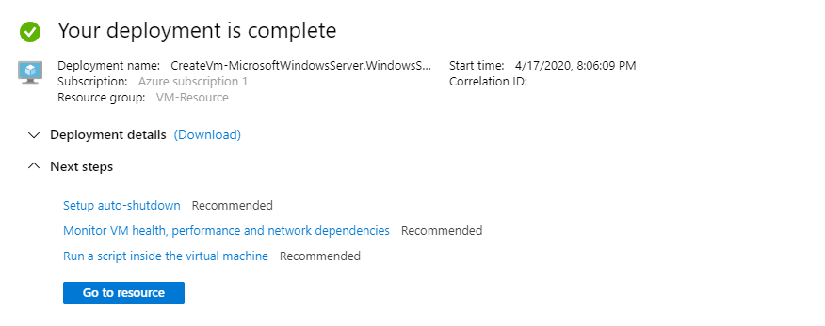](https://res.cloudinary.com/practicaldev/image/fetch/s--wYgMpmHT--/c_limit,f_auto,fl_progressive,q_auto,w_880/https:/cdn-images-1.medium.com/max/880/1*E2wMemb9tMWp5mWfsc8xXw.png)

Navigate to the Virtual machine resource → overview. Here you will see the analytics of your vm for the selected duration.

[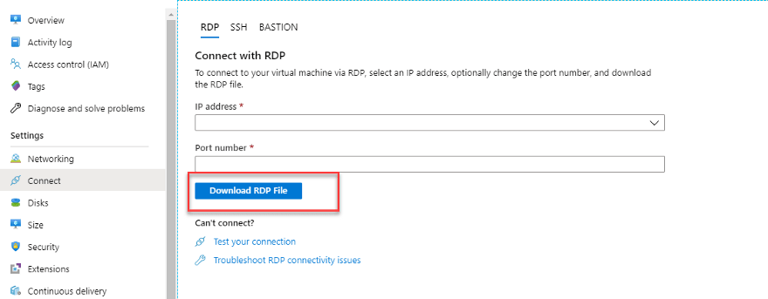](https://res.cloudinary.com/practicaldev/image/fetch/s--ukBzwOTp--/c_limit,f_auto,fl_progressive,q_auto,w_880/https:/cdn-images-1.medium.com/max/880/1*awGnkNZyb2Gjh1-DdcUwvw.png)

(IP address and port should exist. removed for security concerns in above img)

Click on connect and select RDP. Once you are navigated to the connect view, download the RDP file by selecting a public or private IP address as required. Open the downloaded RDP file and click on more choices to use a different account and enter the username and password you entered while creating the virtual machine. This is the local account approach. If the vm is belongs to a domain, enter the {domain/username}. PS: user must be in administrator group or must have remote access privileges.

[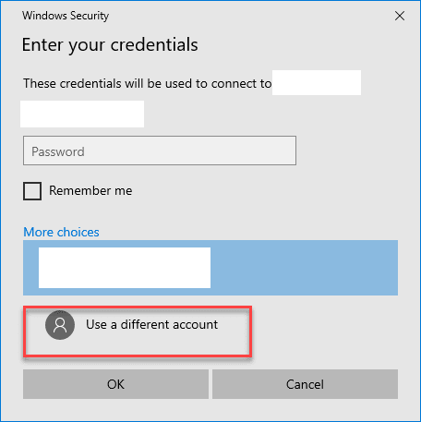](https://res.cloudinary.com/practicaldev/image/fetch/s--jBC40XEs--/c_limit,f_auto,fl_progressive,q_auto,w_880/https:/cdn-images-1.medium.com/max/880/1*seTwBLu9M30ZFbBRBUl8Pg.png)

Now the user is logged into the virtual machine.

#### **Step 4: Setup IIS in azure virtual machine**

After login into the vm follow the following steps.

search for server manager → Add roles and features → Next (Before you begin) → Installation Type (Role based or feature based) → Server selection (Select server from pool) → Server Roles (Enable Web Server (IIS)) → Features (Enable .Net Framework 3.5) → Web server Roles → Role Services (Enable IIS 6 Management compatibility)

Before installation please refer the following figure to ensure you have configured IIS properly. If everything is correct you are good to go.

[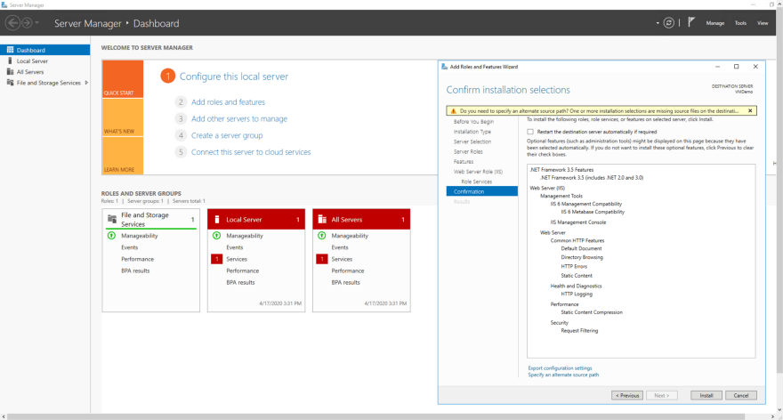](https://res.cloudinary.com/practicaldev/image/fetch/s--EKrYb_sP--/c_limit,f_auto,fl_progressive,q_auto,w_880/https:/cdn-images-1.medium.com/max/880/1*gb1HUU72pSZ1HXQto2GFoQ.png)

Will take some time to finish the installation. Till that you can install the,  
  
[.net core 3.0 hosting bundle](https://dotnet.microsoft.com/download/dotnet-core/thank-you/runtime-aspnetcore-3.0.0-windows-hosting-bundle-installer). If IE does not allow to download the bundle turn off the enhanced security option as follows.

[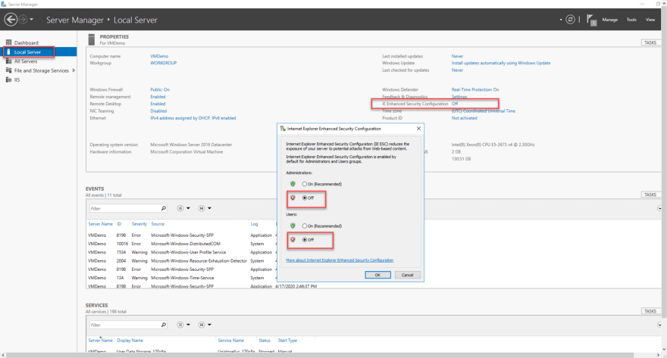](https://res.cloudinary.com/practicaldev/image/fetch/s--vPVc0Kfh--/c_limit,f_auto,fl_progressive,q_auto,w_880/https:/cdn-images-1.medium.com/max/880/1*FzxIFzQbuhz9cpTqfcyHsg.png)

#### **Step 5: Setup release pipeline**

Back to azure devops. In order to deploy the web application to IIS we should create a deployment group and provision a service agent in our windows server 2016 in the virtual machine.

**Deployment group:**

A deployment group represent the environment that the application will be deployed to. It is a set of target machines each having a service agent installed.

Navigate to pipelines → deployment groups in azure devops. Click on +New to create a new deployment group.

[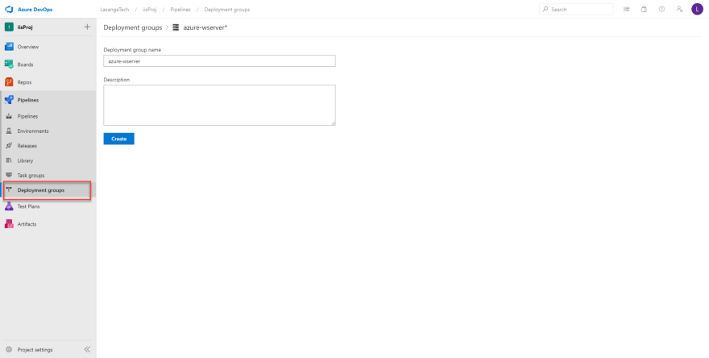](https://res.cloudinary.com/practicaldev/image/fetch/s--ZpMQXYKY--/c_limit,f_auto,fl_progressive,q_auto,w_880/https:/cdn-images-1.medium.com/max/880/1*9cap1Dovq3aXTt0dyzJT9w.png)

Creating a deployment group will automatically create a deployment pool for you. But deployment groups and pools can be shared among projects specifying the scope from tags. For this demo I will continue with the new deployment group and pool.

Now we need to install the service agent into the target machine. To install, the generated script must be executed in the server **powershell as an admin**. To authenticate the script, we must attach the personal access token of the user to the script. Devops will create a token and handle that for you if you check the check box highlighted in the following image. If the token is attached, we are not prompted to enter the authentication type and the credentials. Else will have to provide the type and the credentials.

[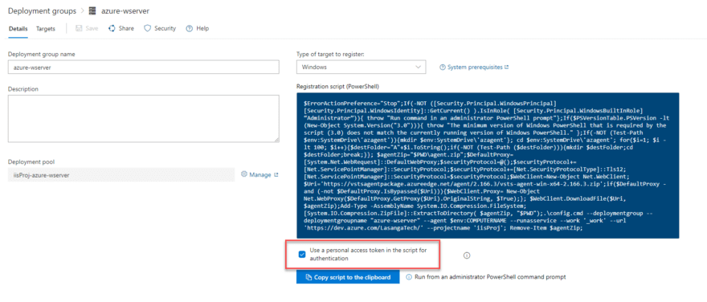](https://res.cloudinary.com/practicaldev/image/fetch/s--phOzbKsO--/c_limit,f_auto,fl_progressive,q_auto,w_880/https:/cdn-images-1.medium.com/max/880/1*a7KWcr8N_1XSRfepzjMcuA.png)

**Note: In azure devops server this option does not exist. Therefore, if you are willing to use the authentication type as PAT, you should create a PAT from devops and give manage and view access permissions.**

Go to virtual machine and open the windows PowerShell as an admin and execute the script copied to your clipboard. Will take few minutes to register the agent.

[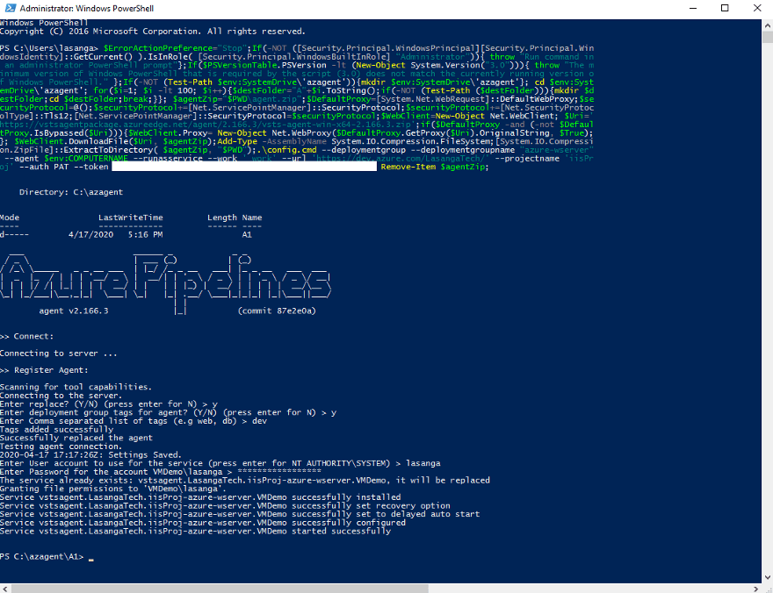](https://res.cloudinary.com/practicaldev/image/fetch/s--csuU_onF--/c_limit,f_auto,fl_progressive,q_auto,w_880/https:/cdn-images-1.medium.com/max/880/1*nRjtP-J-RIAadTXN_c_Vig.png)

As mentioned in the above figure, while registering the agent it will prompt for several requirements.

* Enter replace →y
* Group tags → y
* Add tags → dev, prod (to specify the scope the deployment group will be handling we using tags)
* Add credentials we used while creating the vm as we are logged in to the vm through that account.
* Now check the deployment groups in azure devops. You will see the following. The agent is installed and the group is active.
* [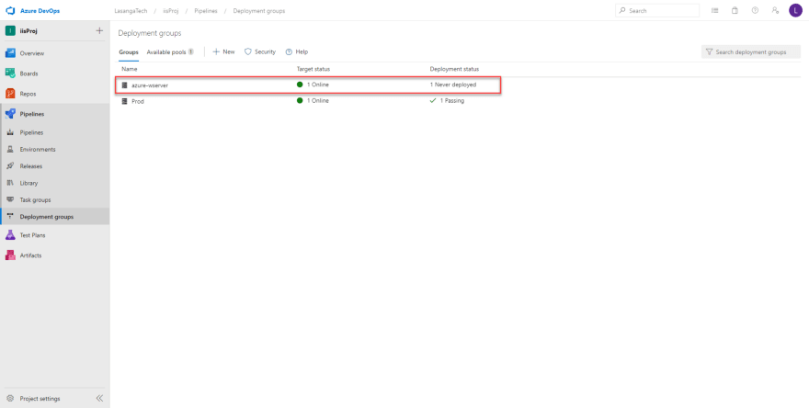](https://res.cloudinary.com/practicaldev/image/fetch/s--ki1jMrHg--/c_limit,f_auto,fl_progressive,q_auto,w_880/https:/cdn-images-1.medium.com/max/880/1*GzCkOgYNtZmnN_VCJS8h7A.png)
* **Step 5: Setup release pipeline**
* We are almost done now. Go to releases → new release if no prior releases. Follow the below images. Will explain after the figures.
* [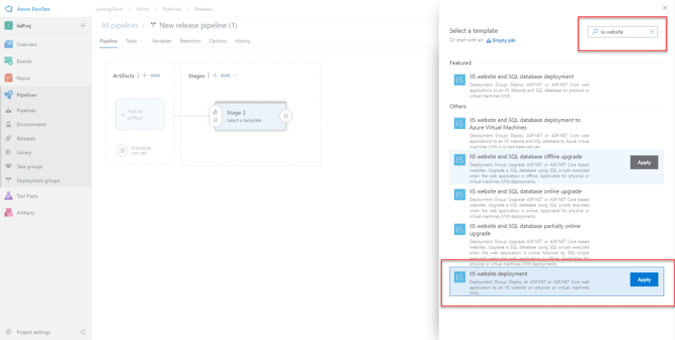](https://res.cloudinary.com/practicaldev/image/fetch/s--xu8arlPU--/c_limit,f_auto,fl_progressive,q_auto,w_880/https:/cdn-images-1.medium.com/max/880/1*oWARM60S28RinYXbMifPNg.png)
* [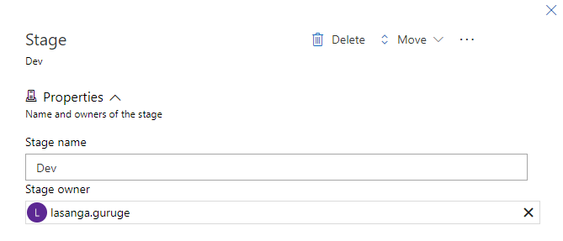](https://res.cloudinary.com/practicaldev/image/fetch/s--MDHV5i25--/c_limit,f_auto,fl_progressive,q_auto,w_880/https:/cdn-images-1.medium.com/max/880/1*_5wIQQ6gvQL4s1XY5Ts2Mw.png)
* Select the add artifacts and add the build pipeline as the reference to this release. Make sure you select the correct build if you have several builds.
* [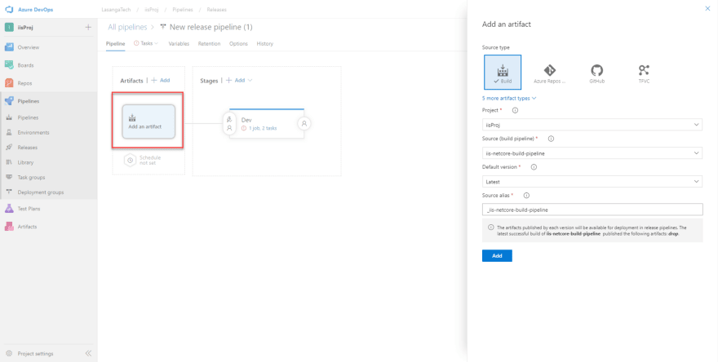](https://res.cloudinary.com/practicaldev/image/fetch/s--vrzFKLtD--/c_limit,f_auto,fl_progressive,q_auto,w_880/https:/cdn-images-1.medium.com/max/880/1*XeM5jlDaAumf3iav7871fQ.png)
* To enable continous deployment, follow the steps below
* [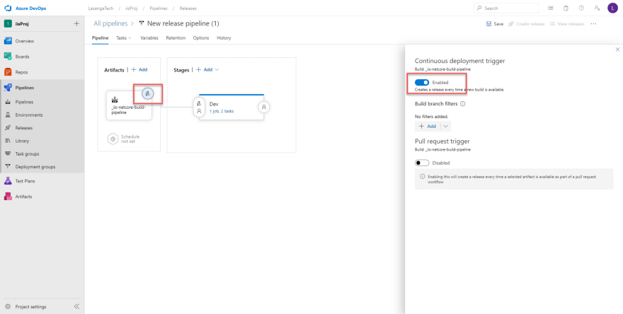](https://res.cloudinary.com/practicaldev/image/fetch/s--jisETa1U--/c_limit,f_auto,fl_progressive,q_auto,w_880/https:/cdn-images-1.medium.com/max/880/1*EOgMeOScUh7UykMztqijxA.png)

Go to the tasks by selecting the link in the stage

* [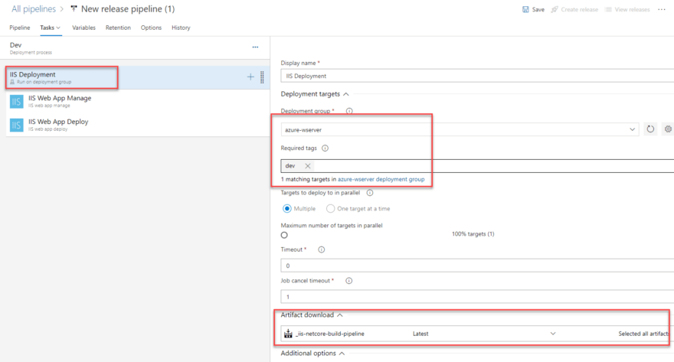](https://res.cloudinary.com/practicaldev/image/fetch/s--qnXOWMHj--/c_limit,f_auto,fl_progressive,q_auto,w_880/https:/cdn-images-1.medium.com/max/880/1*oQO2xlefV7pNRhmjAcZdpw.png)
* Select IIS Deployment and add the correct deployment group we configured. If you need to strictly specify the scope of the deployment use the tags you added while registering the agent. And make sure the artifacts are taken from the correct build.
* Moving onto next task.
* [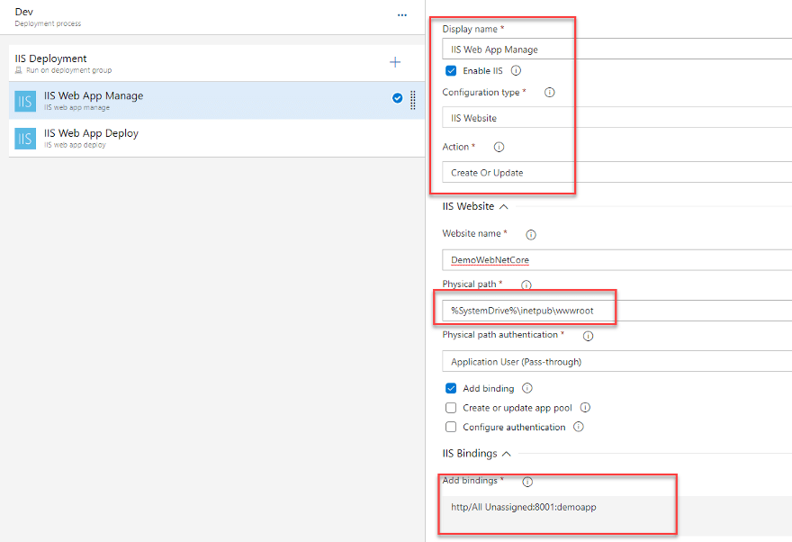](https://res.cloudinary.com/practicaldev/image/fetch/s--6H0Z5g5B--/c_limit,f_auto,fl_progressive,q_auto,w_880/https:/cdn-images-1.medium.com/max/880/1*BsH6ECu4qgDes__1M37JqQ.png)
* Enable IIS check will be a good option to check if the iis is installed in the target machine or not. And action as create or update will check for the existing website with the same name and if exist it will update else will create new one. Make sure the path is correct. it should be the root folder of iis. If you need to customize the url bindings. unlink the parameteres from the Job itself and add as preferred. For now i am keeping the hostname undefined which is equal to the localhost of the iis server.  
    
  Will look into DNS configuration in a future article.
* [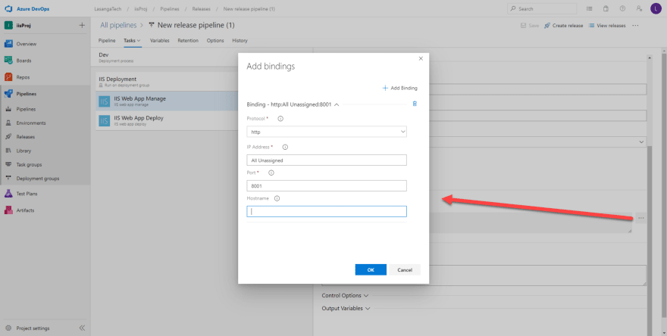](https://res.cloudinary.com/practicaldev/image/fetch/s--KuDHjIlO--/c_limit,f_auto,fl_progressive,q_auto,w_880/https:/cdn-images-1.medium.com/max/880/1*0_8FJ8LiSoIhgZujcm7xTg.png)
* Good to go keep the defaults in deploy task. Now save the configurations and create a release. Select the latest build version and create.
* [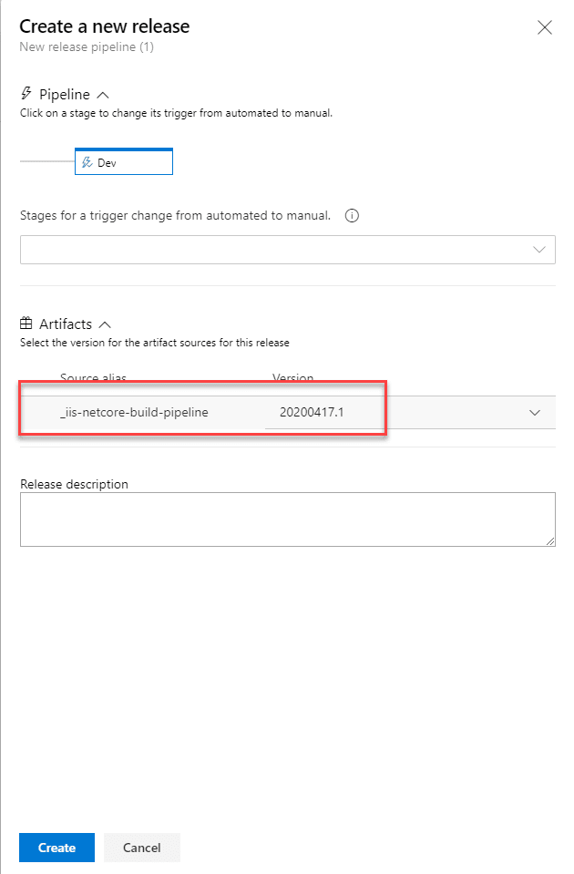](https://res.cloudinary.com/practicaldev/image/fetch/s--YpS9TzOQ--/c_limit,f_auto,fl_progressive,q_auto,w_880/https:/cdn-images-1.medium.com/max/880/1*DUyvoKxZKaH9_8FiiKAuuA.png)
* Navigate to the release displaying in top. click on the logs button to view the logs. Successful deployment will show the below figure.
* [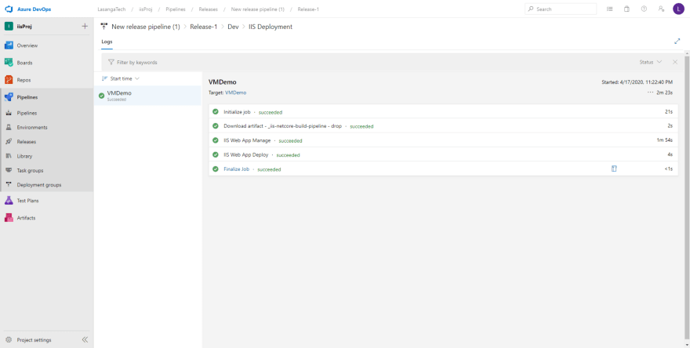](https://res.cloudinary.com/practicaldev/image/fetch/s--hCKOTyrt--/c_limit,f_auto,fl_progressive,q_auto,w_880/https:/cdn-images-1.medium.com/max/880/1*krpUy-pTtRjfJLvHr4vdYA.png)
* As the final step you can navigate to the iis server in azure vm by going to server manager → iis → select server and right click → select iis manager and go to the site deployed and browse.
* [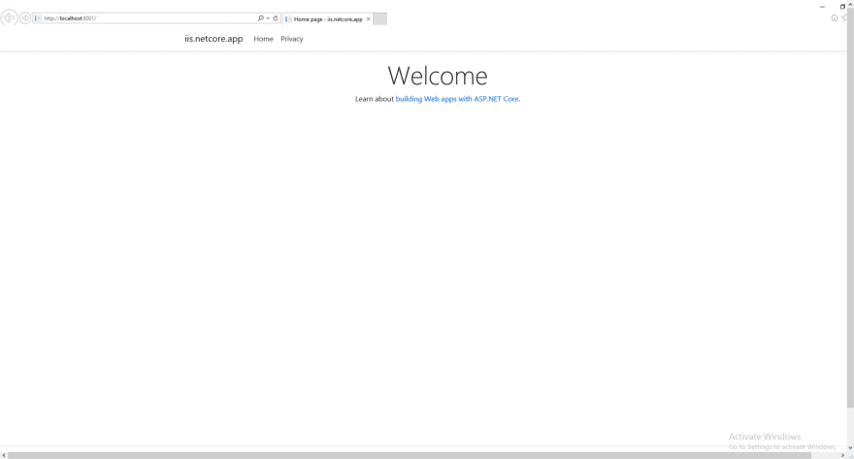](https://res.cloudinary.com/practicaldev/image/fetch/s--lYgnxDd6--/c_limit,f_auto,fl_progressive,q_auto,w_880/https:/cdn-images-1.medium.com/max/880/1*pB-3GWzd9gBAD5CEviDZfg.png)

After this pipeline, you can enable the triggers, make changes in code, commit the code, push the code and you can see build and release pipelines will start automatically, once pipelines got succeeded, you can see the changes in application.

**Create .net application in Azure Webapp:**

## Steps to create CI/CD pipeline

Let us see the steps to implement build automation and deployment automation with Azure DevOps Pipelines.

### **Create Your Azure DevOps Organization**

The first step is to navigate to https://dev.azure.com and sign-in to Azure DevOps. You need to create at least an organization to store your projects, your repositories.

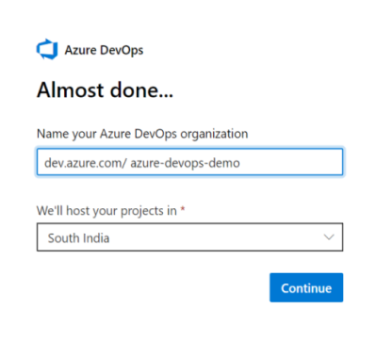

### **Create a Project**

Please create an Azure DevOps project by selecting values like visibility, source control etc.

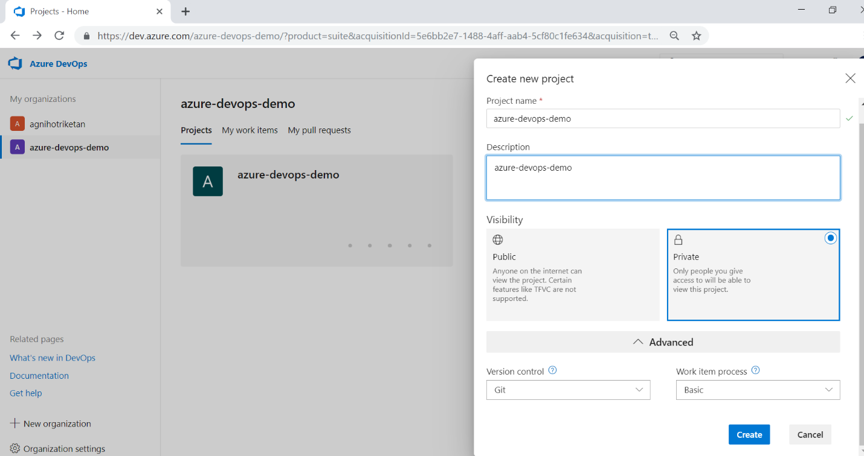 Figure 3. Create an Azure DevOps Project

Now push the code to your azure repos, as explained earlier,Once it’s done go to azure devops, and open pipeline.

Please select build option from pipeline menu to set up build pipeline.

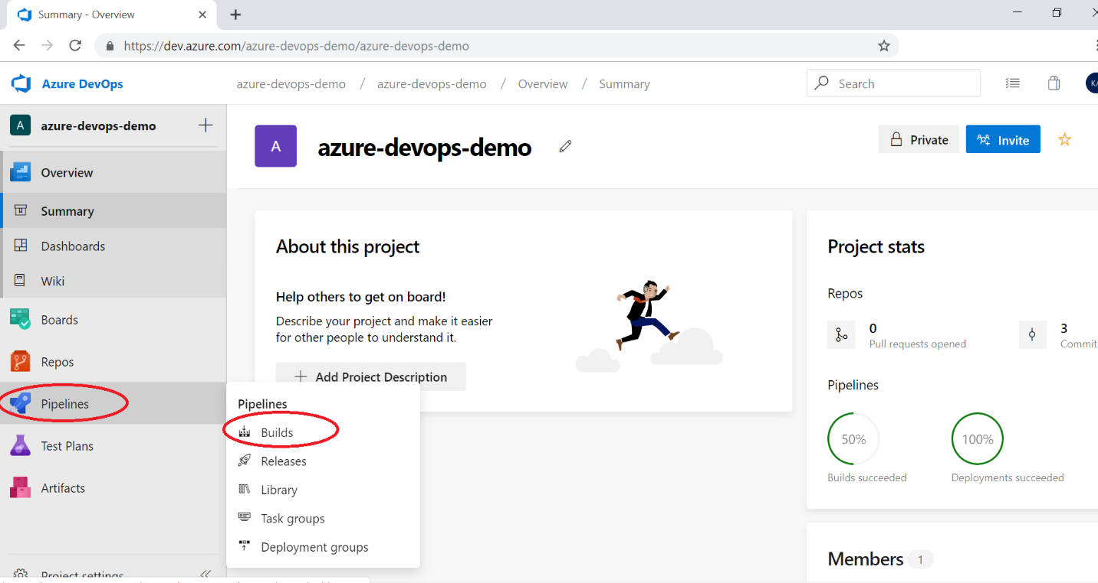

Now choose a build template provided by Azure DevOps as shown below.

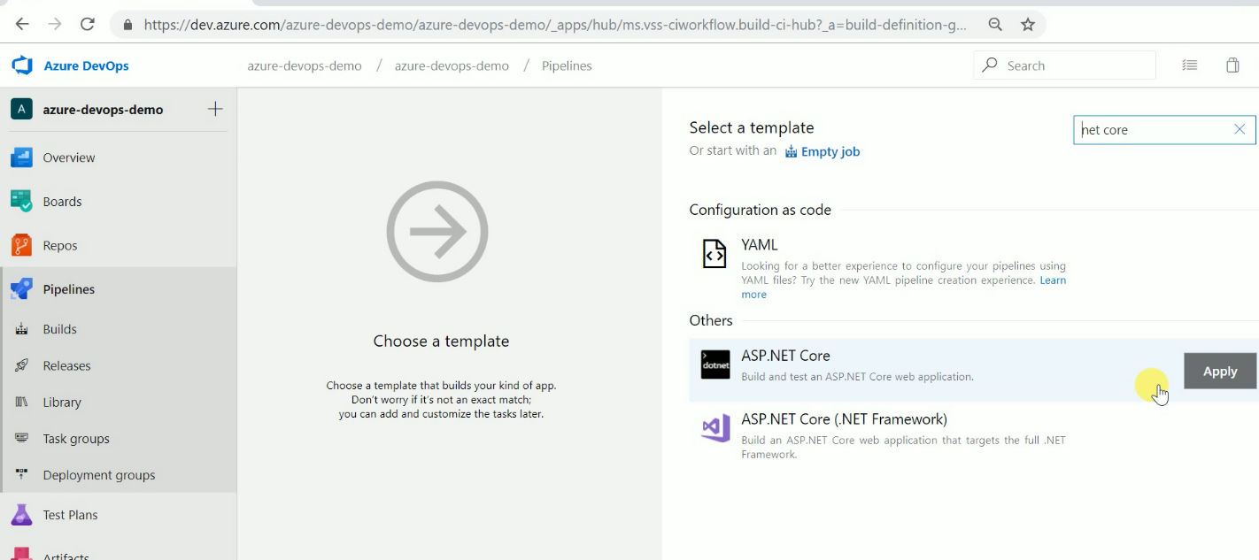 Figure 6. Choose build template

I can also select the TFVC version control system or GitHub if I want to as source code. Now give a name to build definition. Please select an appropriate solution file to build & location to save build artifacts. These artifacts will be used as input to release pipeline. You can see which artifacts. Azure DevOps provides multiple predefined templates to build application developed in java, node.js, Php etc.

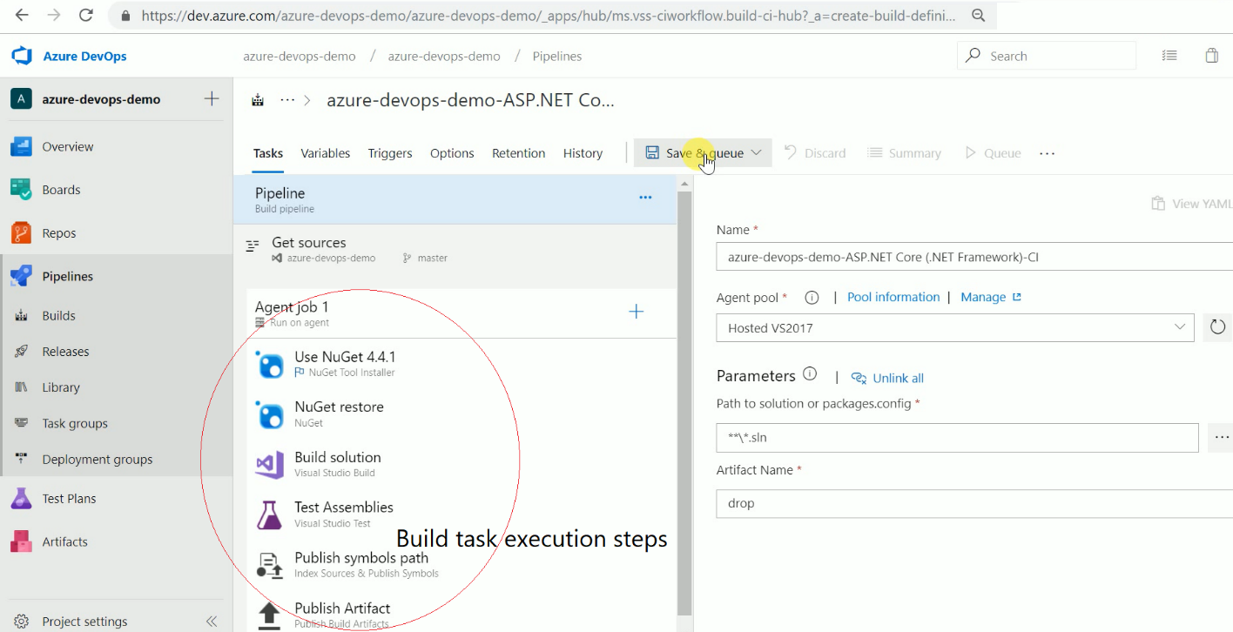 Figure 7. Queue a build

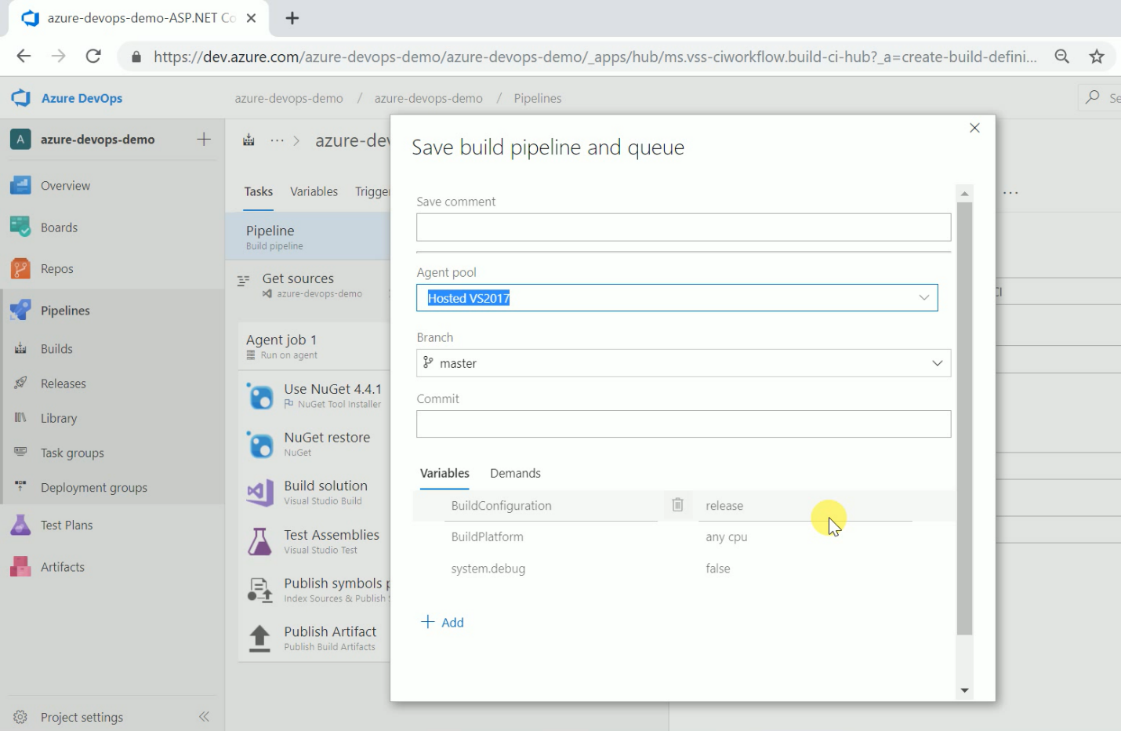

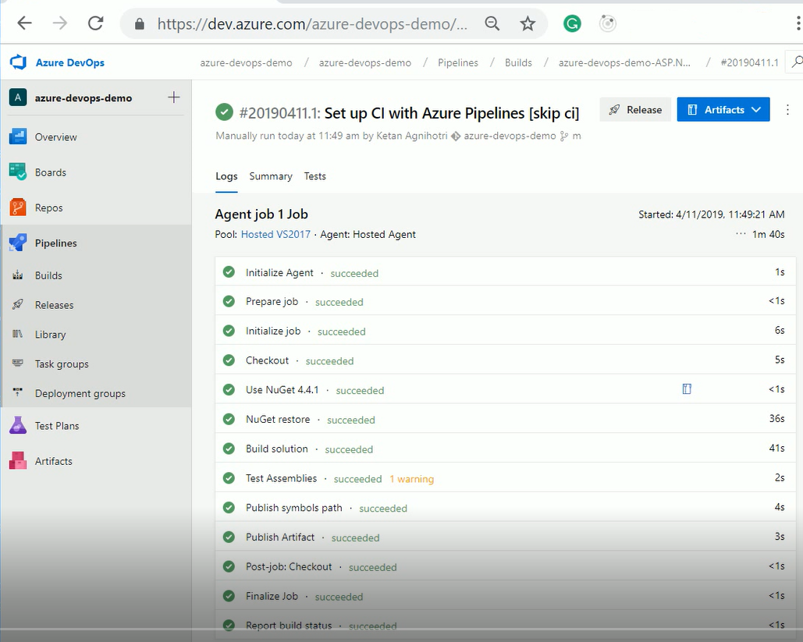 Figure 7. Build Completed

### **Create a Release Pipeline**

Now once build succeeded, we need to create release definition. You can select release menu from the pipeline or click on the release button as shown below. When you get into the release pipeline screen, you’ll need to select a template.

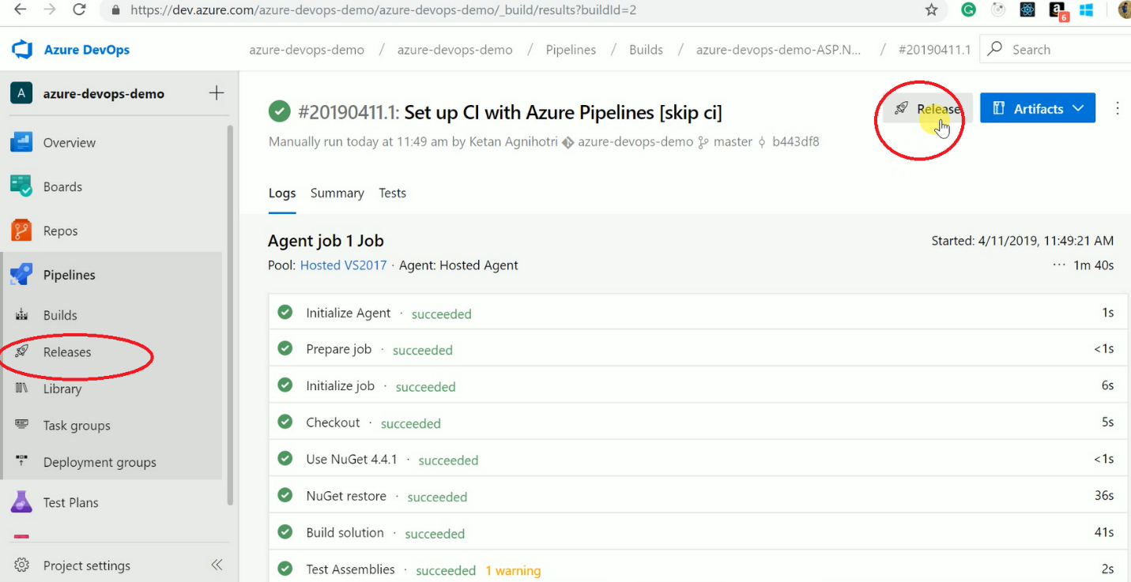 Figure 8. Create Release Pipeline

Azure DevOps has provided a lot of predefined templates for deployment. Some of them are as follows

1. Azure App Service Deployment with Test and without Test
2. Azure App Service Deployment with continuous monitoring
3. Cloud Service Deployment
4. On-Premise deployment
5. Azure VM Scale Set
6. Service Fabric (Stateful/ stateless)
7. Azure Policy deployment
8. Function App to Azure

We can create our own custom template as well as per our requirement.

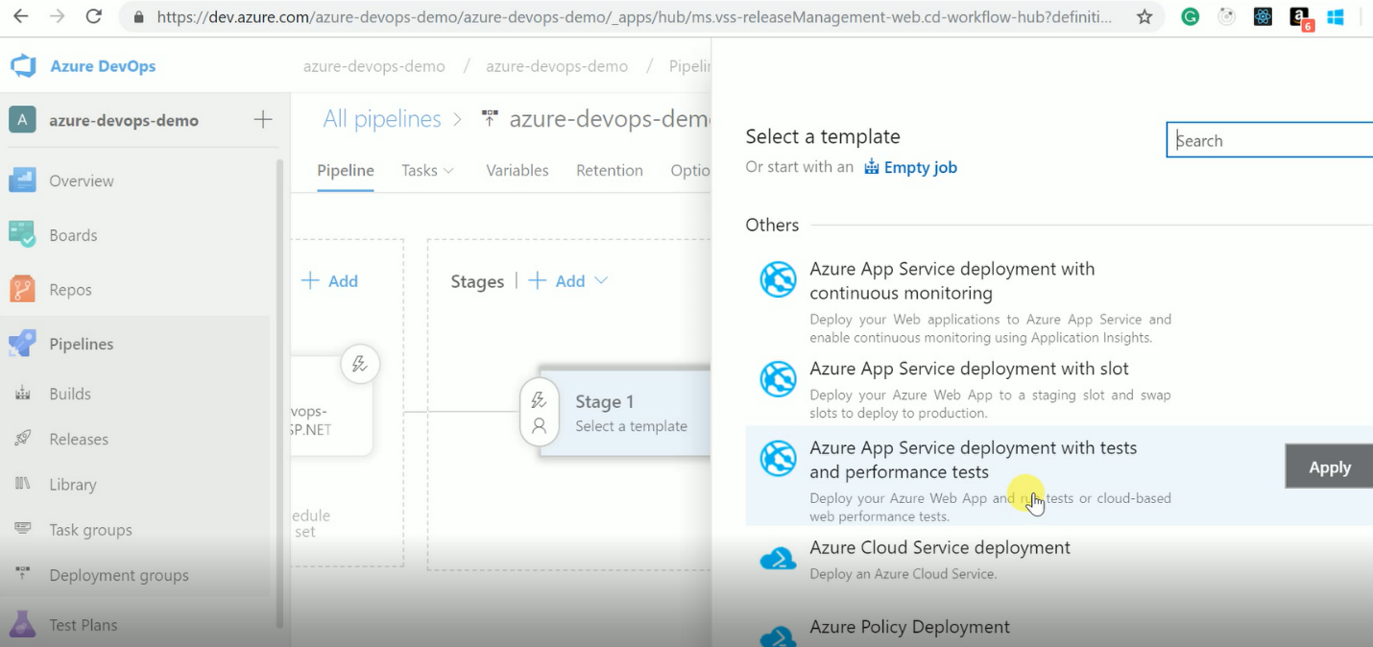 Figure 9. Choose Release Template

After selecting the template, we can add task so that we can deploy a build multiple environments like dev, test, UAT etc. We can add particular use as a release approver as well. We can set the variable values which are used in the release definition. You can convert those templates to YAML in a later stage as well and then check in version control if you want. You see that there are all kinds of pre-defined templates to do your builds. So for example, a Gradle build or a Go build, or you want to do some load testing, or you want to do Xamarin app for iOS, Ant builds, you name it; it's all there and part of the out-of-the-box experience. Azure DevOps has things like NuGet restore, Test Assemblies, Build the solution, all kinds of things that we can pick from the task picker.

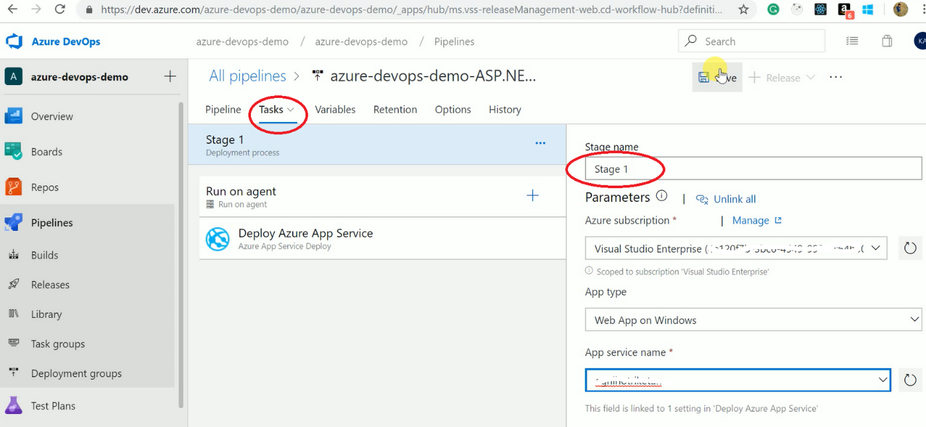 Figure 10. Add tasks to Release Definition

After saving the release definition, you can create a new release. You can choose environments for release if you have added multiple release tasks.

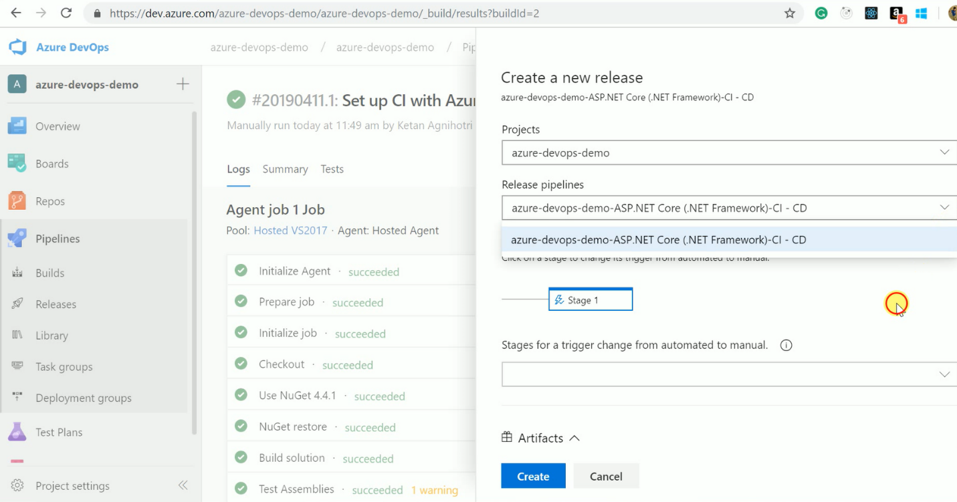 Figure 11. Create New Release

After creating a release, we can track release progress as shown below.

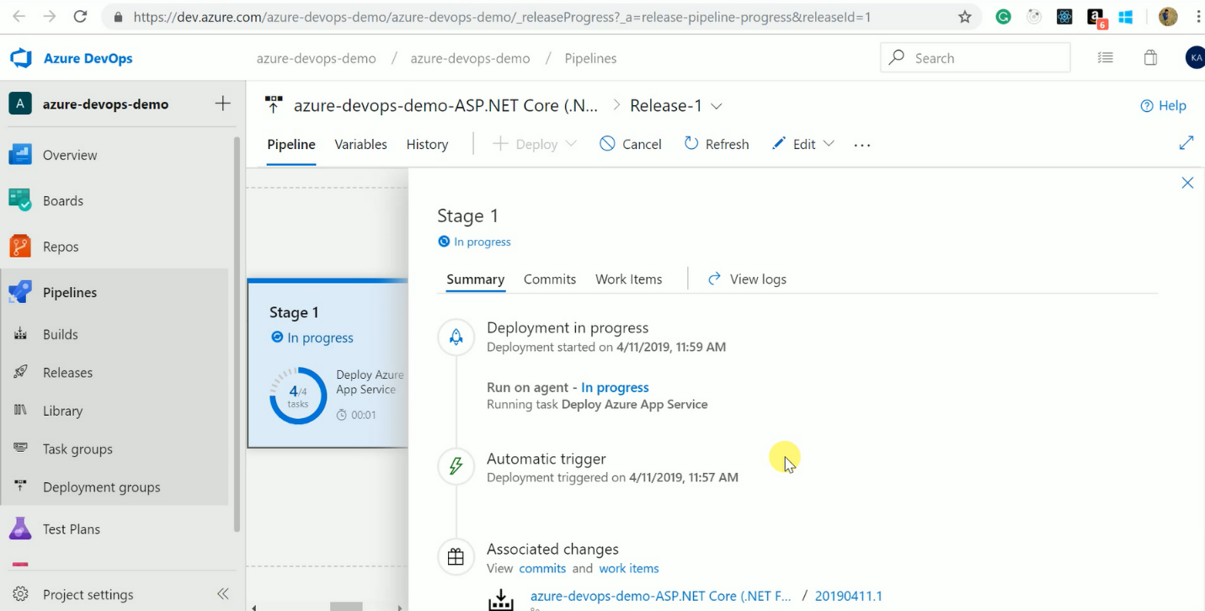 Figure 12. Check Release Progress

We can enable pre-deployment approvals as shown below. Now, what happens when I did a deployment and the deployment failed? Well, I can select to re-deploy the previous well-known stable deployment so I'm always in a good state again, which is quite handy. So that's a way we can define those post approvals before we move to the next phase in our deployment.

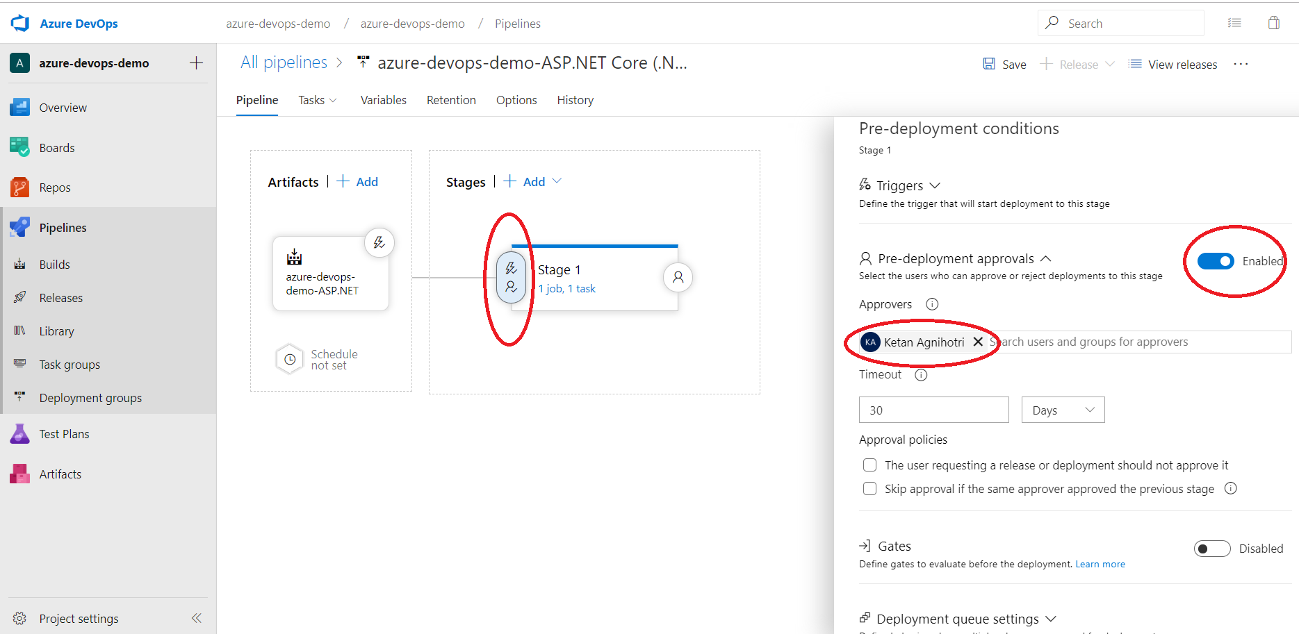 Figure 13. Enable Pre-Approval for Deployment

**Pipeline History**

We can also look at the history where we can track the changes that are made to the release definition, which is also very handy if it comes to compliance and security. Now we can clone those different environments, because after and you want to do the same in let's say dev, as in staging as in test or production. We have different triggers here and one of the triggers is that we wanted to have continuous integration. So every time, changes in our Git repo, I want to trigger build/Release pipeline. We can also schedule things in Azure DevOps.

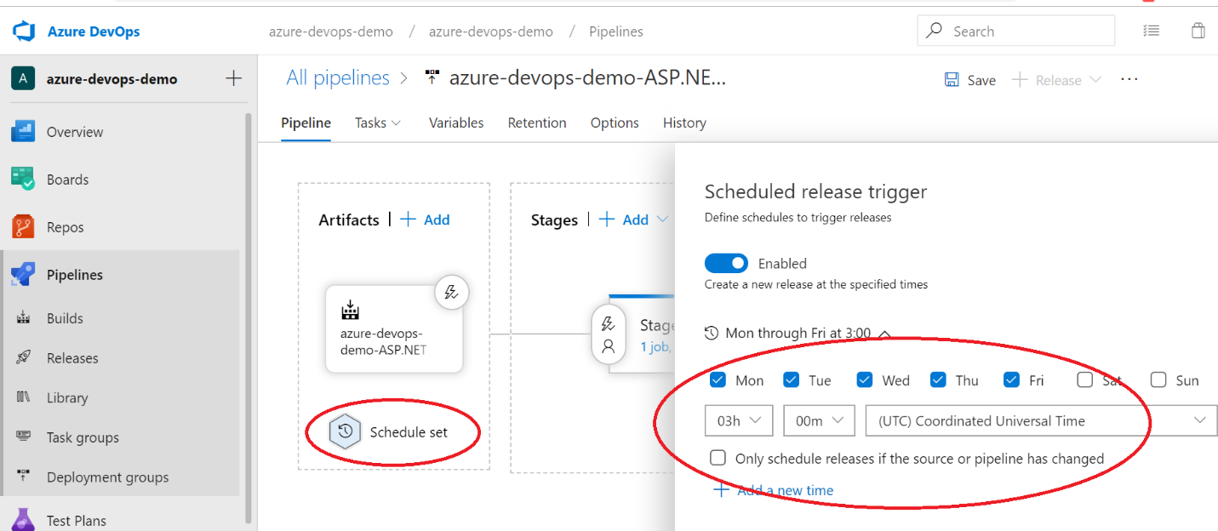 Figure 14. Schedule Release

After successful completion of a release pipeline, you can visit the deployed version of your application.

**Go to the azure portal, open your web application and browse the url for example**

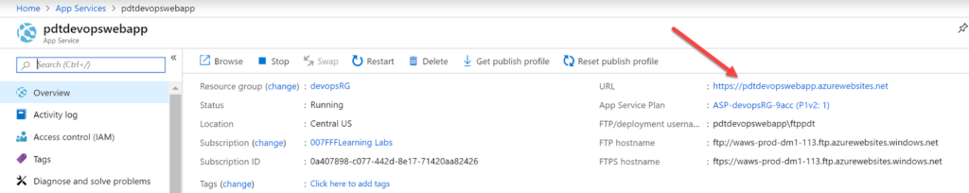

**Create CI CD pipeline from github repo for .net core by using yaml method and deploy into Azure webapp**

If you’re planning on walking through this Project, step by step, be sure, at a minimum, you have the following:

* [**An Azure account**](https://azure.microsoft.com/en-us/free/search/?&ef_id=Cj0KCQjwrMHsBRCIARIsAFgSeI2Y8p9u2z9lLJjrL80sMThoQG2-FYXL73dAA6vzsFop8uCv_RQqihYaAtwAEALw_wcB:G:s&OCID=AID2000128_SEM_5nJSB71e&MarinID=5nJSB71e_286296264948_create%20azure%20account_e_c__55956187097_kwd-310735070824&lnkd=Google_Azure_Brand&gclid=Cj0KCQjwrMHsBRCIARIsAFgSeI2Y8p9u2z9lLJjrL80sMThoQG2-FYXL73dAA6vzsFop8uCv_RQqihYaAtwAEALw_wcB)
* Already logged into the [**Azure Portal**](https://portal.azure.com/) with global administrator or similar rights.
* A [**GitHub**](http://www.github.com/) account
* An empty **[Github repository created](https://help.github.com/en/articles/create-a-repo)**
* [**An empty Azure WebApp**](https://azure.microsoft.com/en-us/get-started/web-app/) deployed using dotnetcore 2.2 and Linux for the platform

## Creating an Azure DevOps Organization

Because we’re starting from absolute scratch, you’ll first create the “base” object that all Azure DevOps features and services are contained within called the [**organization**](https://docs.microsoft.com/en-us/azure/devops/organizations/accounts/organization-management). The organization is where all projects are stored which you’ll learn how to build in the next section.

1. From the [**Azure Portal**](https://portal.azure.com/), browse to **All services**, search for DevOps and select **Azure DevOps.** You can see what to expect below. This will open the **Azure DevOps** blade as you can see below.

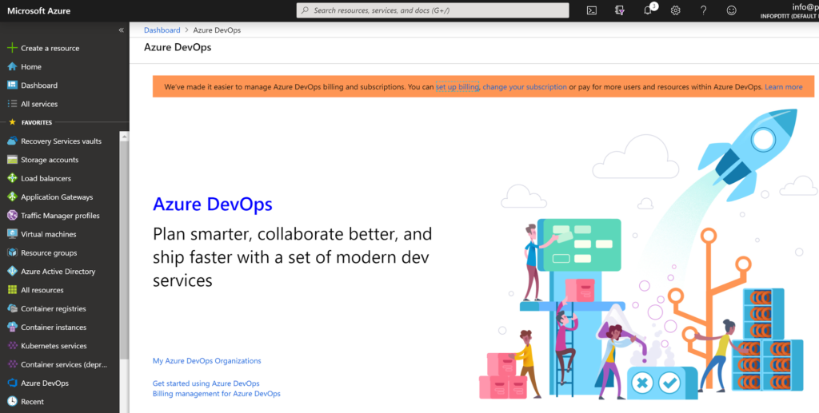

Azure DevOps dashboard

2.  Next, click **My Azure DevOps Organizations** and provide your Azure credentials. You will be brought to a page where you can create a new organization as shown below. Once here, click on the blue **Create new organization** button.

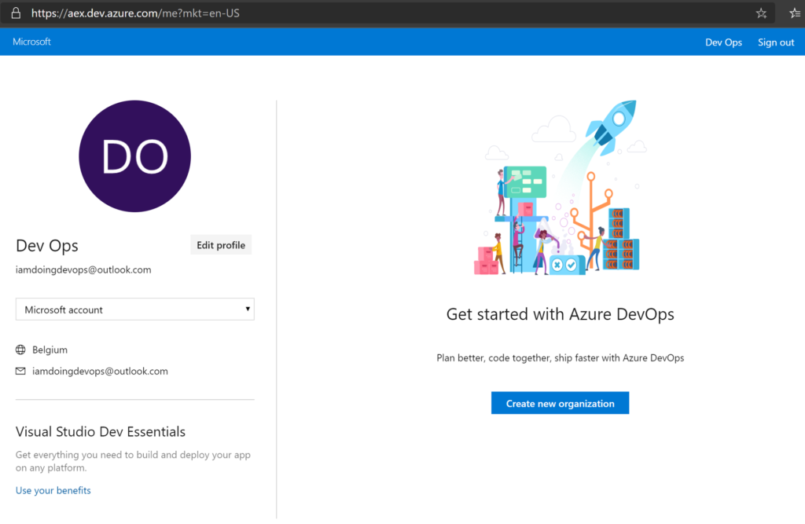

3.  On the next page, provide a name for the organization. If you run into problems with using a specific name, be sure to check the [**Azure DevOps organization naming conventions**](https://docs.microsoft.com/en-us/azure/devops/organizations/settings/naming-restrictions?view=azure-devops). On this screen, also specify an Azure region closest to you. Once done, click **Continue**.

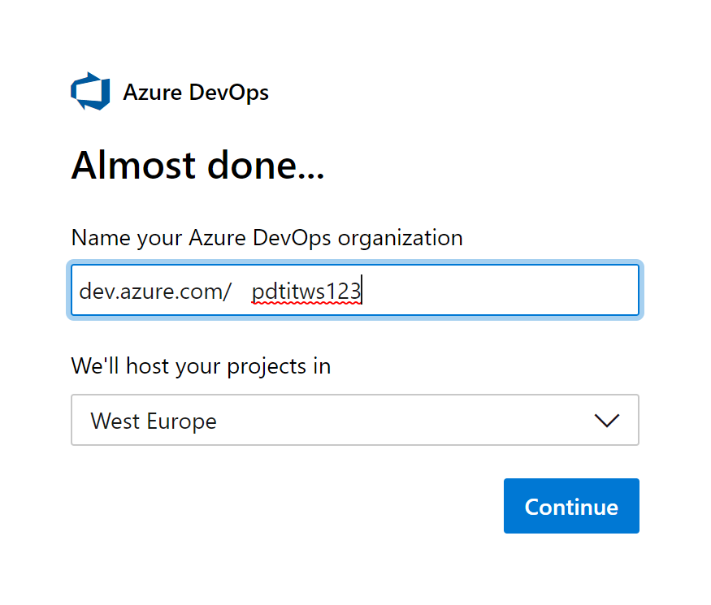

At this point, your Azure DevOps organization is created!

## Creating an Azure DevOps Project

The next step is creating a project. A project is a container for the pipeline you’ll be created, various artifacts and any other information pertaining to a particular service or piece of software.

Azure DevOps gives you the ability to create a project during the same workflow as creating an organization as performed above. If you followed along, you should now be presented with a project creation page as shown below.

1. On the project creation page, provide a name for your project in the Project name field. For this project, you’ll be using an Azure DevOps project called devopsdemo.
2. Confirm the creation of the project by clicking the + Create Project button.
3. For now, leave the Visibility set to Private. This ensures your project isn’t exposed to the Internet. A public project allows non-members of a project and non-signed-in users read-only access to the project’s artifacts.

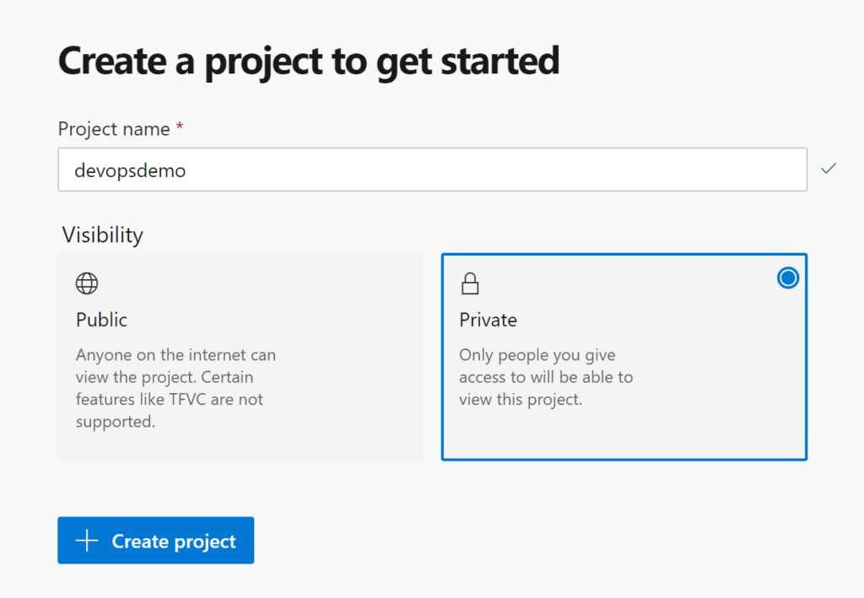

At this point, your Azure DevOps workspace (project + organization) has been created. If you’ve been following along, you will now have an Azure DevOps organization created called pdtitws123 and a project inside of that organization called devopsdemo.

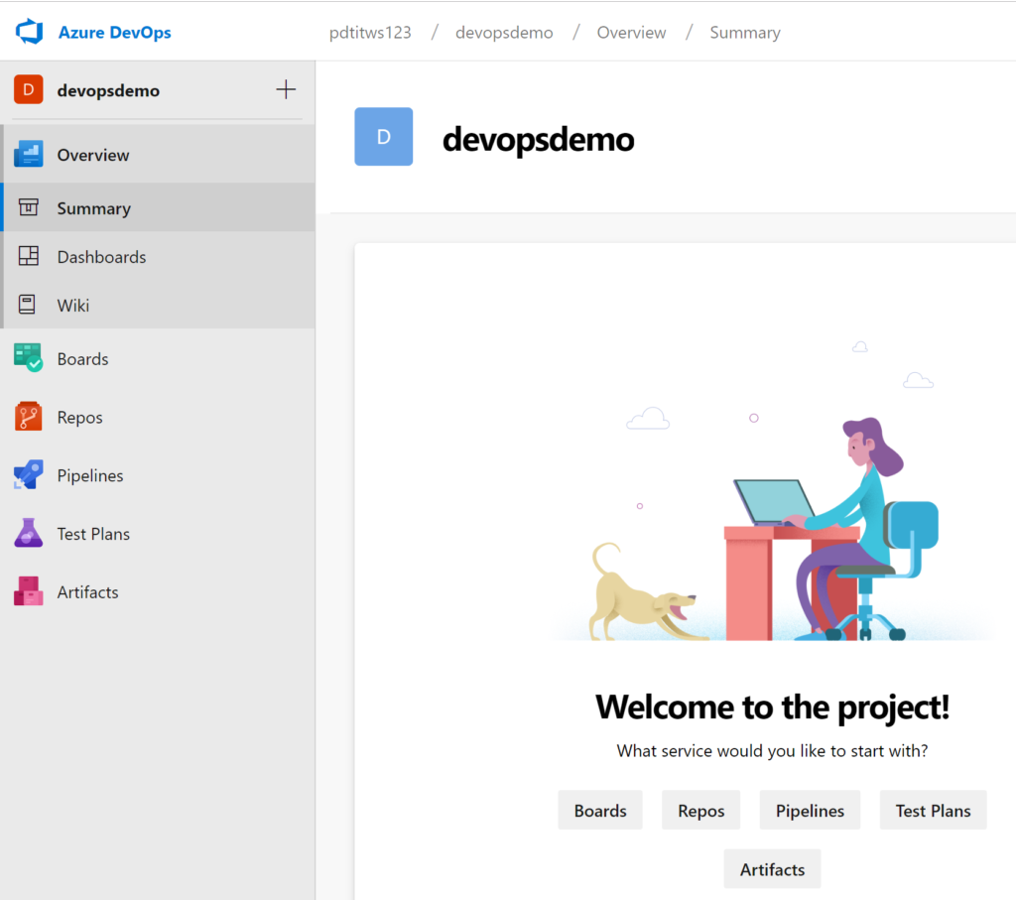Azure DevOps project overview

## Building an Azure DevOps Build Pipeline

Now that you have an Azure DevOps organization and project set up, you can now create a build [**pipeline**](https://azure.microsoft.com/en-us/services/devops/pipelines/) inside. The pipeline is where all the magic happens. It’s where you will create builds to perform various tasks like compiling code, bringing in dependencies and more.

1. From the dashboard, select **Pipelines** then on **Builds**.

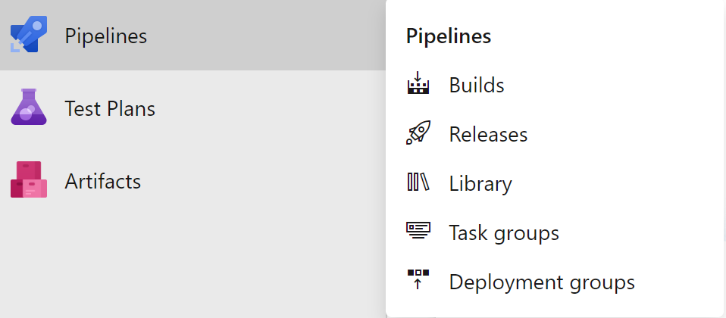

2.  You will see a message telling you there are no build pipelines found yet. Click on **New pipeline** to begin creating the build pipeline.

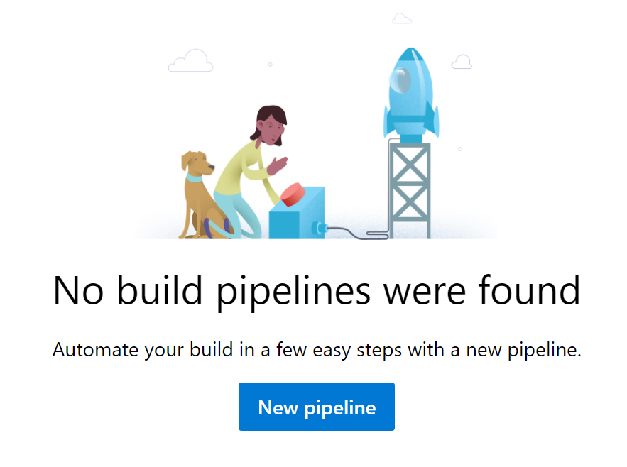3.  You will then be prompted for where your code is stored. In this Project, the code is stored in a GitHub repository. Select **GitHub**. This is the place where code is stored and the triggers for invoking the build will come from.

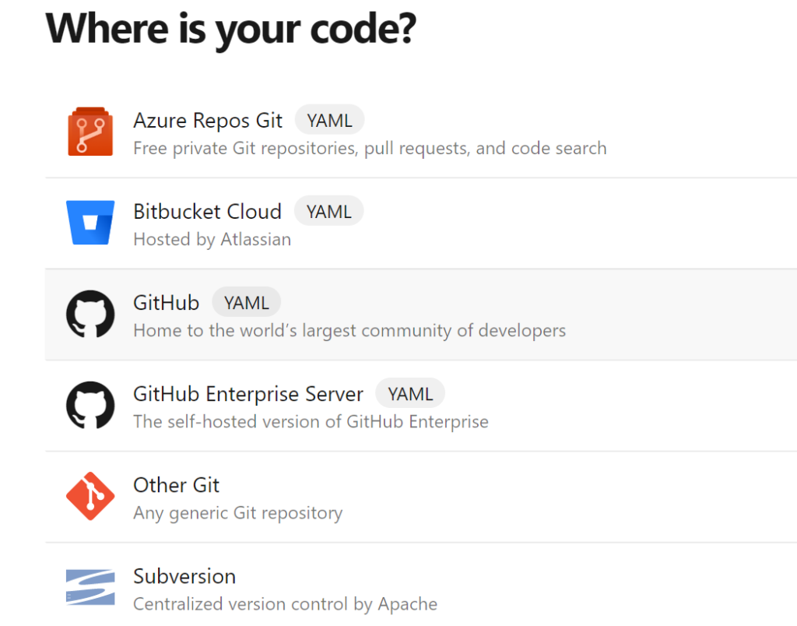4.  Once you click on **GitHub**, you’ll be prompted to provide your GitHub account credentials as shown below. Before you begin this step, remember to have an empty GitHub repo created as defined in the Prerequisites section of this article!

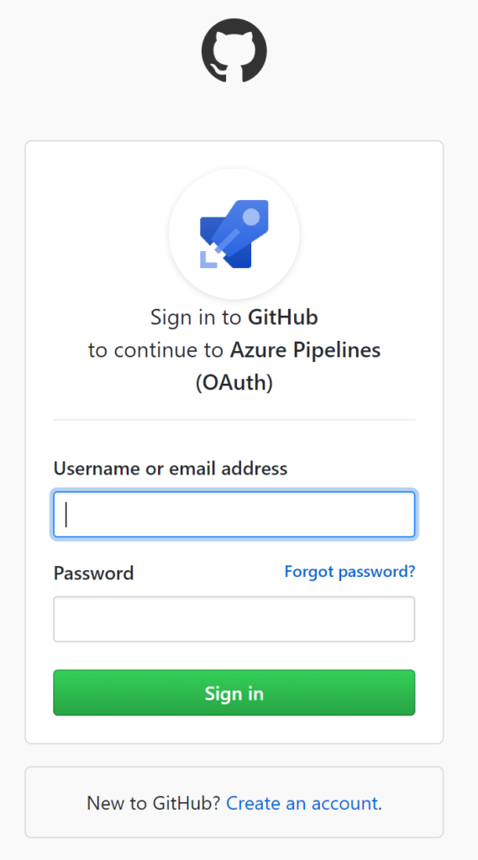

5.  Next, confirm the step where you are asked to authorize Azure Pipelines. This ensures Azure DevOps has permission to access your GitHub repos.

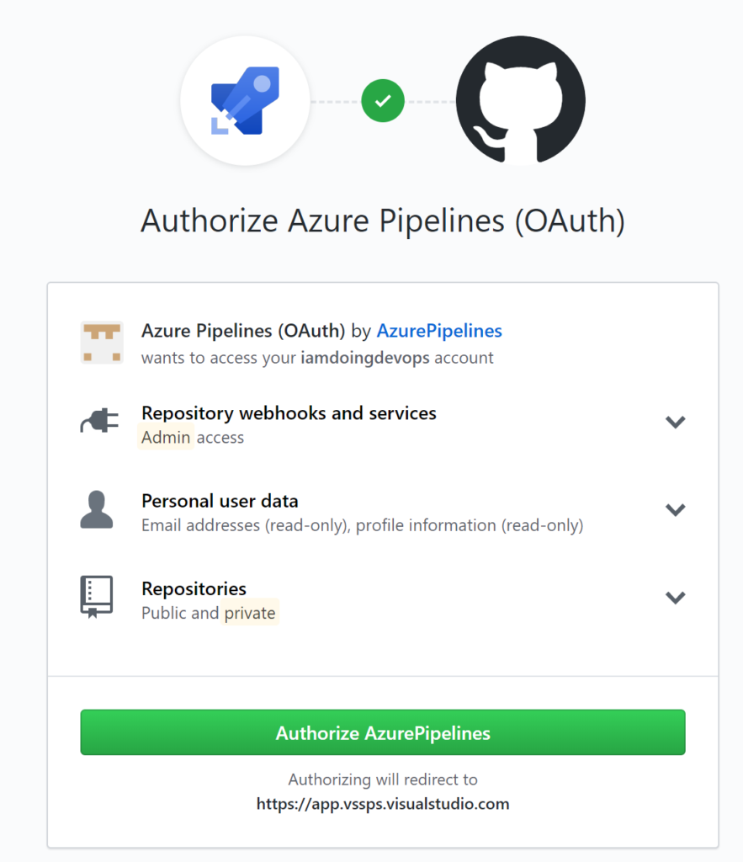Authorizing Azure Pipelines to access GitHub

### Linking a GitHub Repo to the Build Pipeline

Once you’ve provided Azure DevOps permission to your GitHub account, now link a GitHub repo to the build pipeline.

1. Select the empty GitHub repo you have created for this Project.

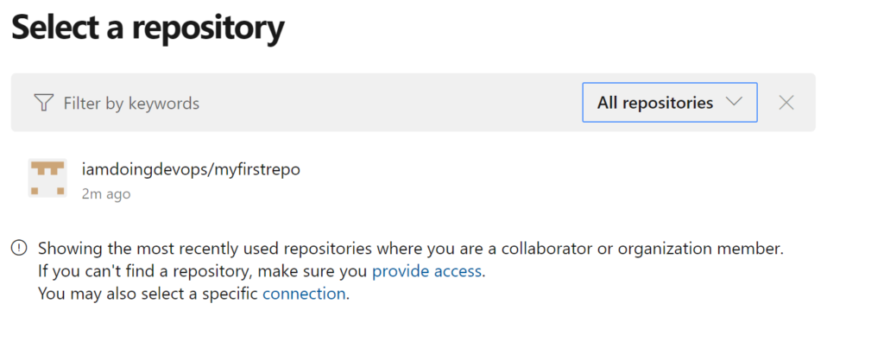Empty source GitHub repo

2.  Allow the project to read, write and check source code from the repository you selected earlier. Then confirm this process by clicking **Approve & Install**.

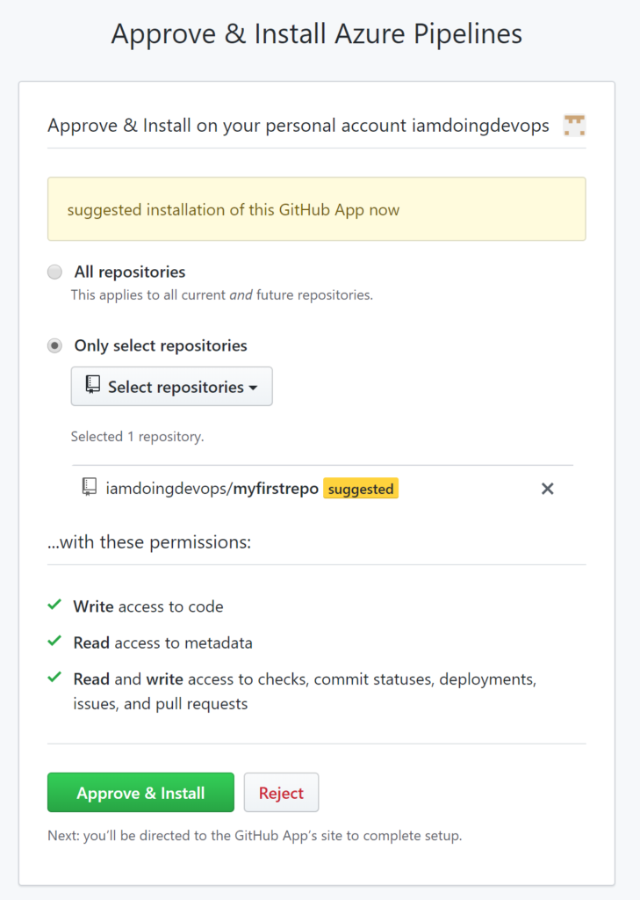

Confirm Azure DevOps Github integration

3.  By clicking confirm, you will see an error generated as shown below. This error will happen because the GitHub Repo selected is empty.

3.  By clicking confirm, you will see an error generated as shown below. This error will happen because the GitHub Repo selected is empty.

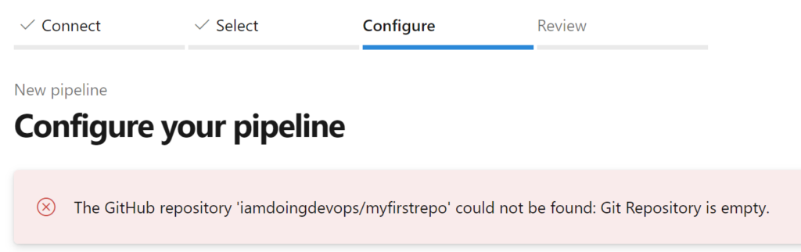Error when GitHub repo is empty

At this point, your GitHub repo will be linked to your Azure DevOps build pipeline.

You don’t have to create an entirely new pipeline every time you want to link a GitHub repo to an Azure DevOps build pipeline.

### Populating Sample GitHub Repository Code

The Azure DevOps build pipeline won’t run without some code in the GitHub repo. The code doesn’t necessarily matter at this point. To get some code in the repo, we’ll use an existing repo to clone some code from. In this repo, I have all the source code available to publish an e-commerce sample application in Azure WebApps.

The sample code for this repo will contain a sample e-commerce application called **[SimplCommerce](http://www.simplcommerce.com/)**. This application is an open-source dotnetcore application that’s more realistic than the typical “hello world” project.

1. Navigate to [**this sample GitHub repo**](https://github.com/iamdoingdevops/myfirstrepo) and click on Import code as shown below.

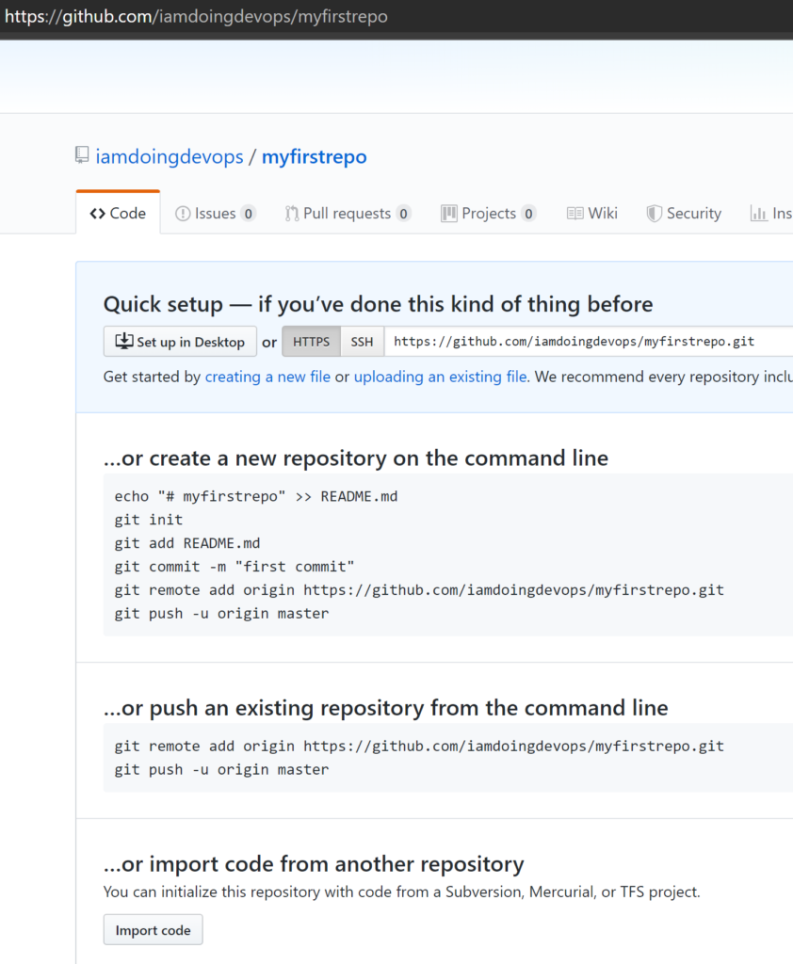

Empty myfirstrepo GitHub repo

2.  For the **old repository’s clone URL** use [**http://github.com/007FFFLearning/SimplDev**](http://github.com/007FFFLearning/SimplDev) and click on **Begin import**.

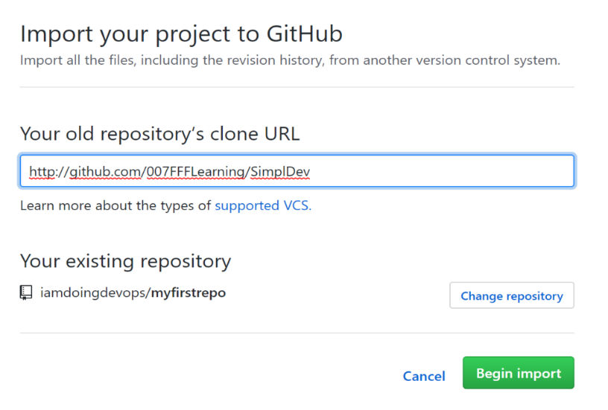

Proving the repo clone URL

When the repo import step is completed successfully, refresh the [**Azure DevOps Pipeline**](https://adamtheautomator.com/azure-devops-pipeline-infrastructure/) window, which should allow you to continue now.

### Inspecting and Viewing the Build Pipeline in YAML

At this point, you will be at the Review phase of the pipeline creation process. You will now be presented with a representation of the build pipeline in YAML. This YAML file is automatically built based on the detection of the source code language which is dotnetcore in this Project.

One of the real benefits of Azure DevOps is the pipeline YAML. With many other DevOps tools, you have to build a pipeline file manually.

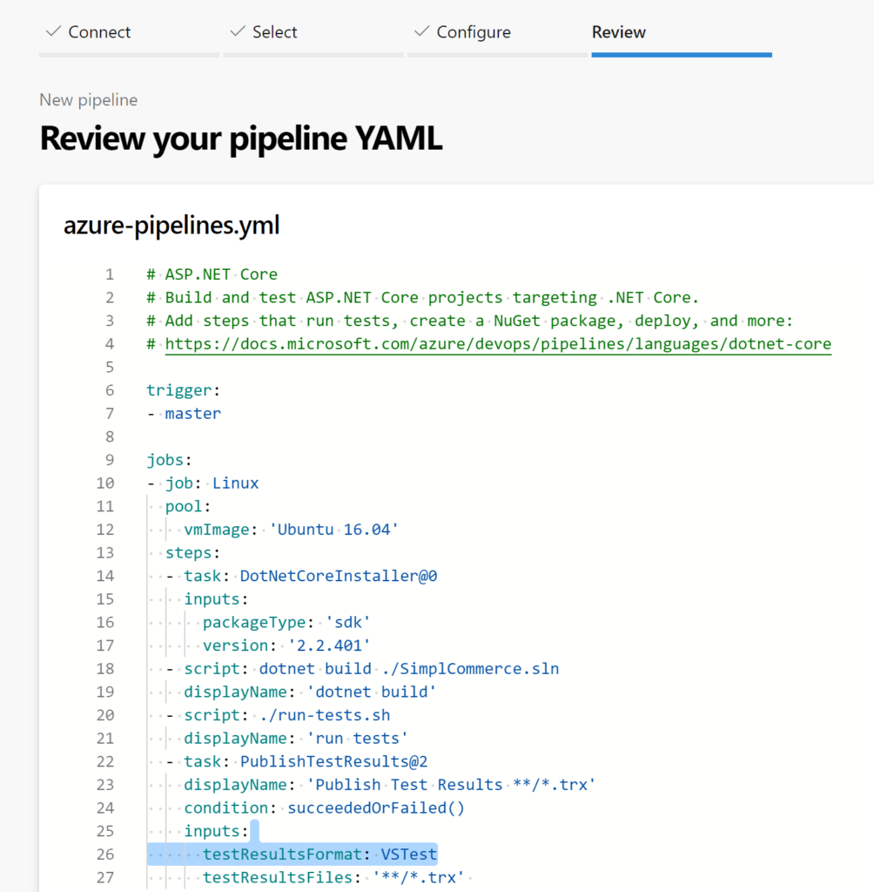Reviewing pipeline YAML

## Manually Running the Azure Build Pipeline

In a [**continuous integration (CI) pipeline**](https://semaphoreci.com/blog/cicd-pipeline), the build is typically triggered by a commit to source control. But, you can also manually trigger the build pipeline to run. Let’s kick off a build pipeline manually to see what happens.

If you’ve been following along, at this point, you should be to the point where you can click on **Run** to kick off the build pipeline. This will start the pipeline build process as you can see from the below screenshot.

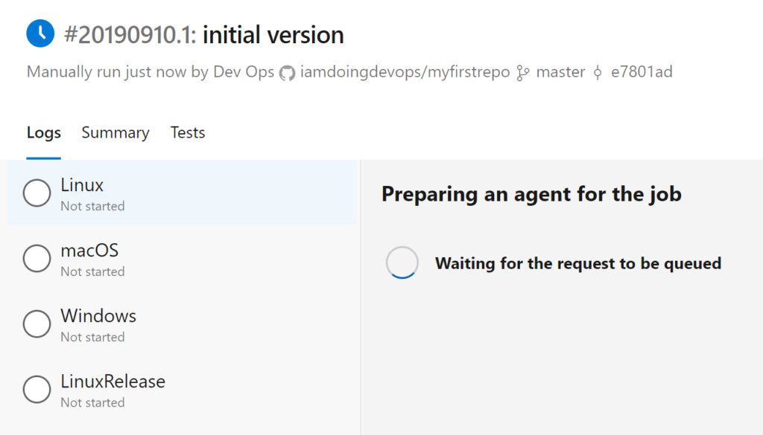Pipeline starting

After a few seconds, you can see that the process will be running for macOS as shown below. The build pipeline will return information in real-time as each job and task in the pipeline runs.

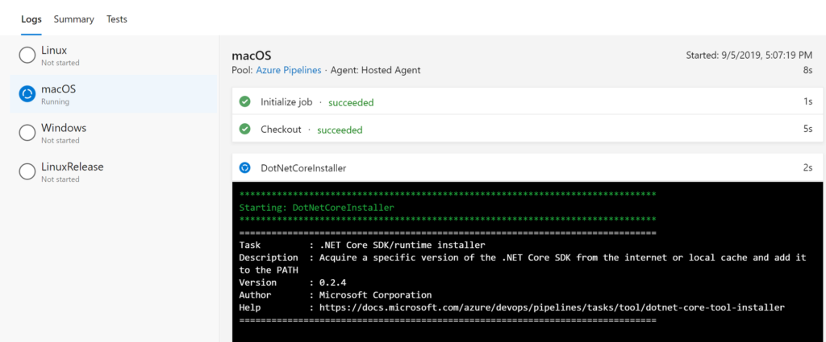Running on the macOS build agent

The build pipeline will then repeat the same process for the other operating systems (in this example) as shown below. The steps taken will vary greatly depending on how the YAML file was built.

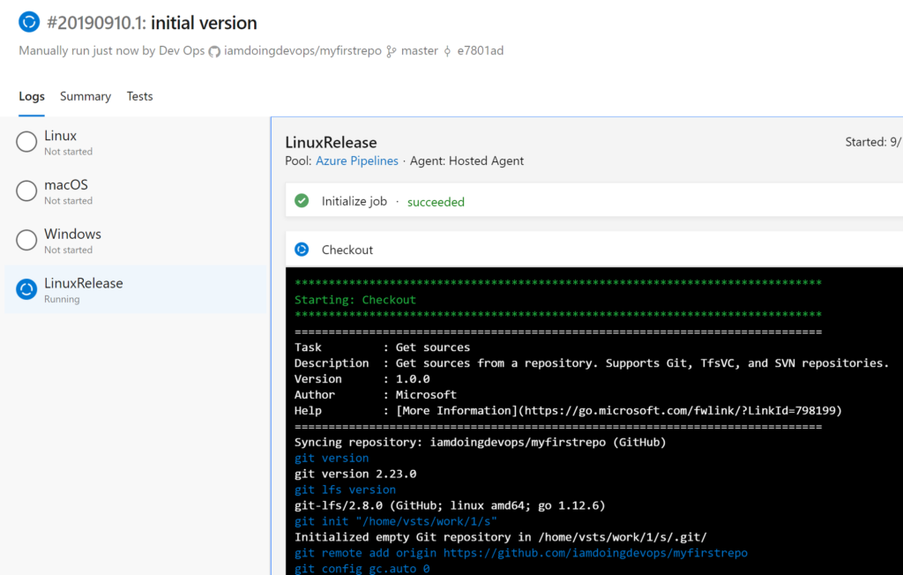Running on the Linux build agent

Once the build has completed, you are greeted with green checkmarks as you can see below. This screenshot indicates each platform build passed successfully.

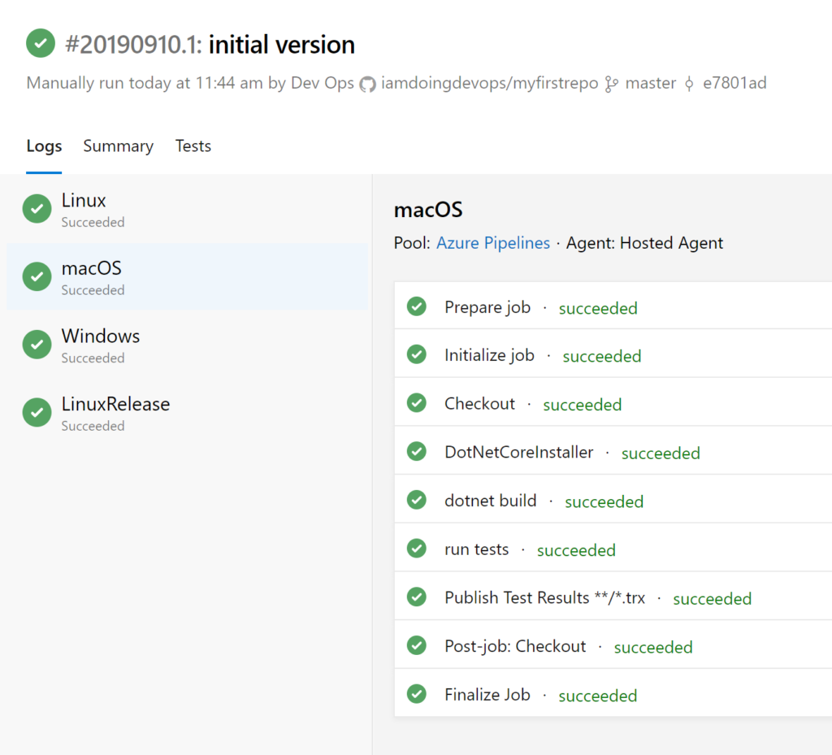Successful pipeline run

You’ve now created an Azure DevOps build pipeline!

## Building an Azure DevOps Release Pipeline

The build pipeline is created which is some great progress. If you were to stop at this point, you’d be well on your way for a complete, automated pipeline. But we’re not done! The ultimate goal of software needs to be deployed so customers can use it. It’s time to automate a release too with a [**release pipeline**](https://docs.microsoft.com/en-us/azure/devops/pipelines/release/)!

A release pipeline takes a build artifact, a result of the build process and deploys that to one or more environments. In this Project, you’re going to use a release pipeline to publish code in the GitHub repo to an Azure Web App.

From Azure DevOps, click **Pipelines** and then **Releases**.

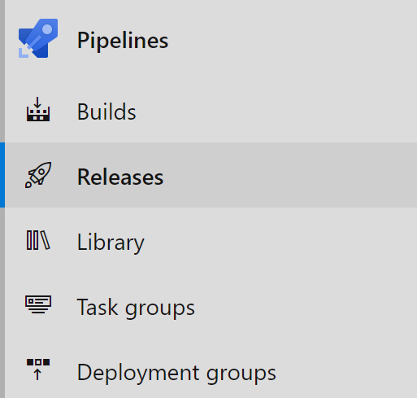

Releases menu item

2.   Next, select **New** and then **New Release Pipeline**. This launches the New release pipeline wizard.

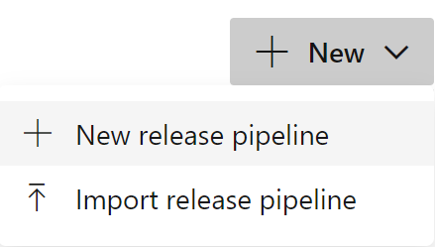New release pipeline menu option

3.  From the template list on the right, select **Azure App Service Deployment**. You’ll see many different kinds of templates available to save time creating future release pipelines.

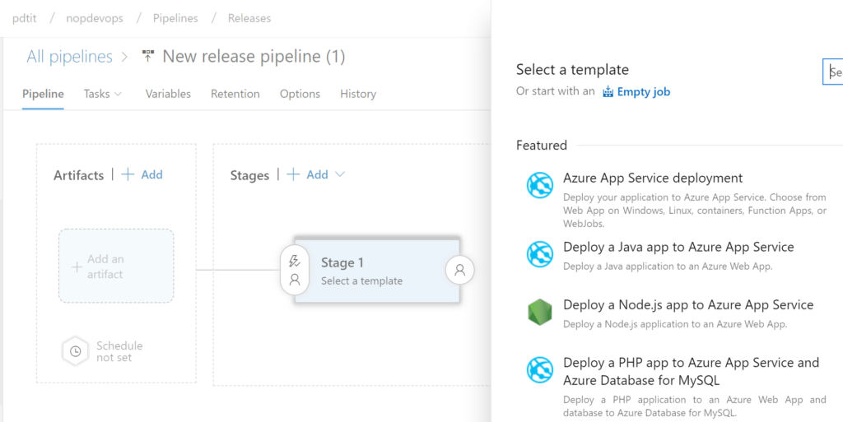Select the Azure App Service deployment template

4.  Provide a description for the **Stage Name.** The stage will contain release tasks. For this project, use the name Deploy_to_webapp.

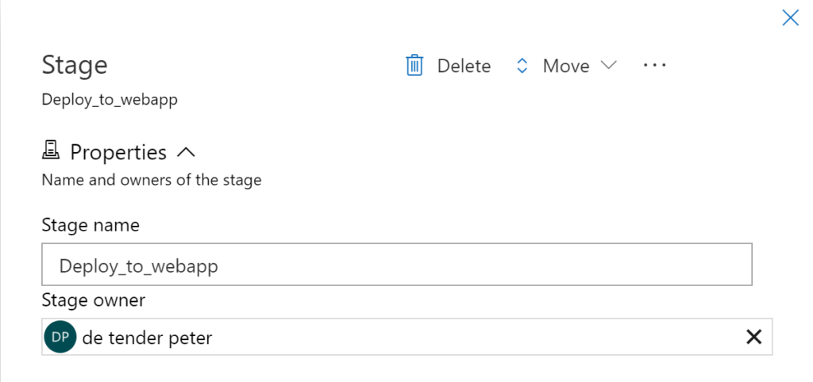Specify the stage name

The release pipeline should now look like the below screenshot.

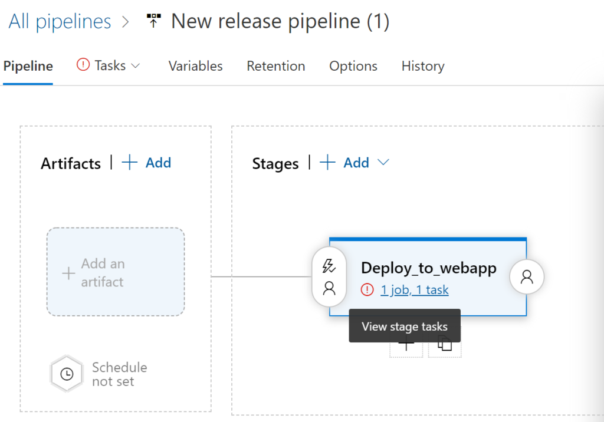Created stage

5.  In the Stages field, select **1 job, 1 task**. This field is where you will eventually provide the settings of the Azure Web App environment you will use for the actual deployment.

6.  Part of the Azure App Service deployment template comes a few parameters you’ll need to define in this screen.

1. Stage Name – Deploy-to-webapps2 in this example.
2. Azure Subscription – select your subscription and confirm with **Authorize** (needs credentials)
3. App type – Web App on Linux
4. App Service Name – the web app you created earlier

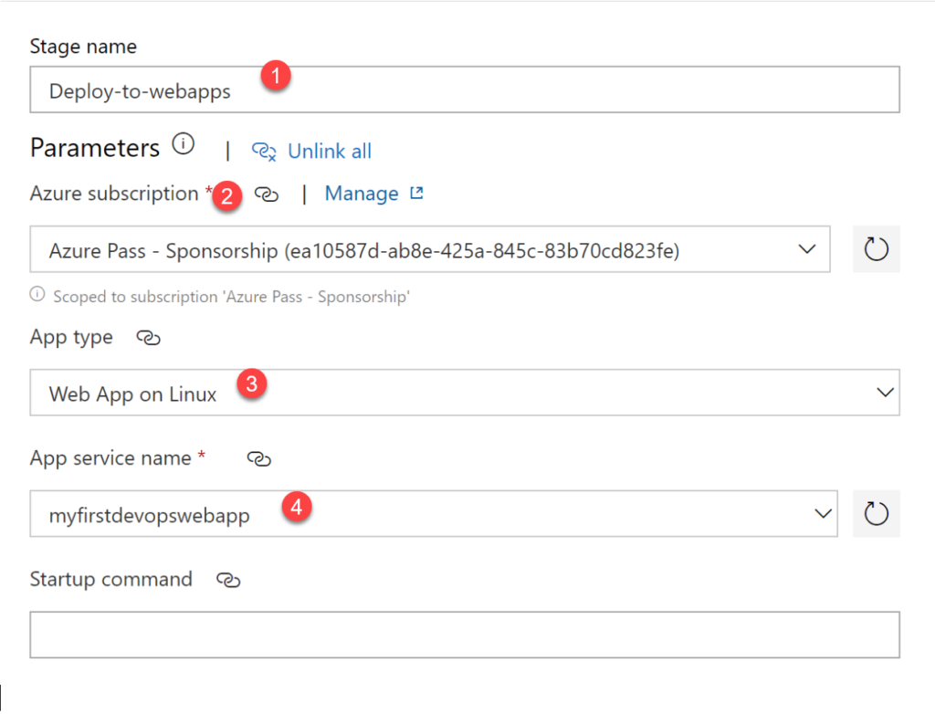Setting template parameters

7.  When done, click **Pipeline** in the top menu of your Azure Pipeline project as shown below. This will return you to the main screen and allow you to complete the next step which is specifying the [**artifacts**](https://docs.microsoft.com/en-us/azure/devops/pipelines/release/artifacts).

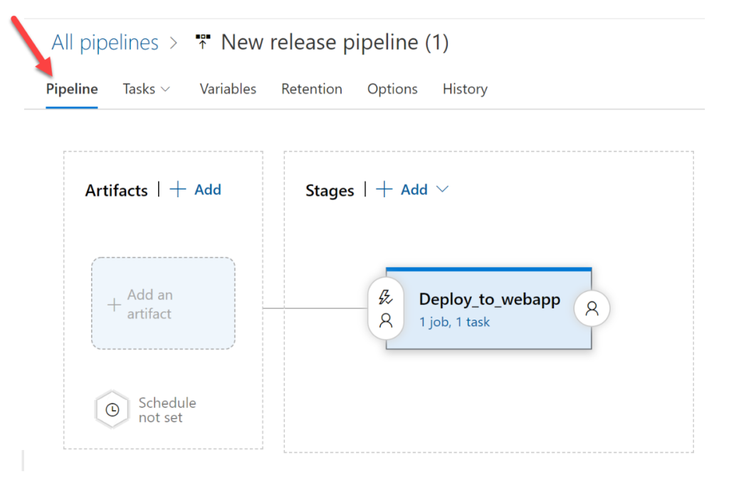

Going back to the pipeline

### Adding Artifacts to the Azure DevOps Release Pipeline

Within a release pipeline, there are many different items that need to be deployed. These items are called [**artifacts**](https://docs.microsoft.com/en-us/azure/devops/pipelines/release/artifacts?view=azure-devops). Artifacts put simply, are deployable components of your application. Azure Pipelines can deploy artifacts that are produced by a wide range of artifact sources.

In this section, let’s cover how to add artifacts to the release pipeline.

1. While on the **Pipeline** screen, click on **Add an Artifact**.
2. The **Source Type** is already set to **Build** which is what you want since you’ll be deploying the output of the build pipeline created earlier. Choose the build pipeline created earlier in the **Source (build pipeline)** dropdown.
3. When finished, click on **Add** to save the configuration.

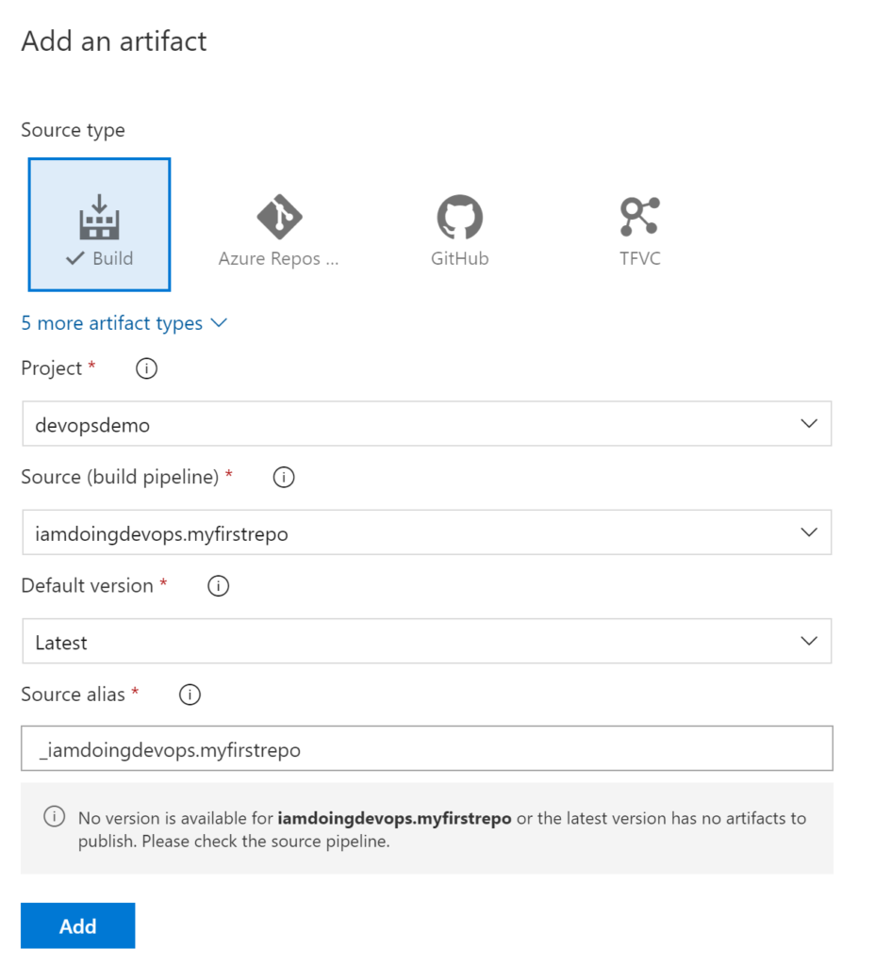

Adding an artifact

4.  Finally, click on the **Save** button in the upper right corner of the screen to save the release pipeline.

## Creating the Azure DevOps Release

Once the release pipeline is created, you’ll then begin creating releases. A release is a particular run of the pipeline. Think of the release pipeline as the template and specific instances of that release pipeline as releases. Once you have a release, that release can then be deployed.

To create a release:

1. Click the **Create Release** button in the upper right corner of the window as shown below.

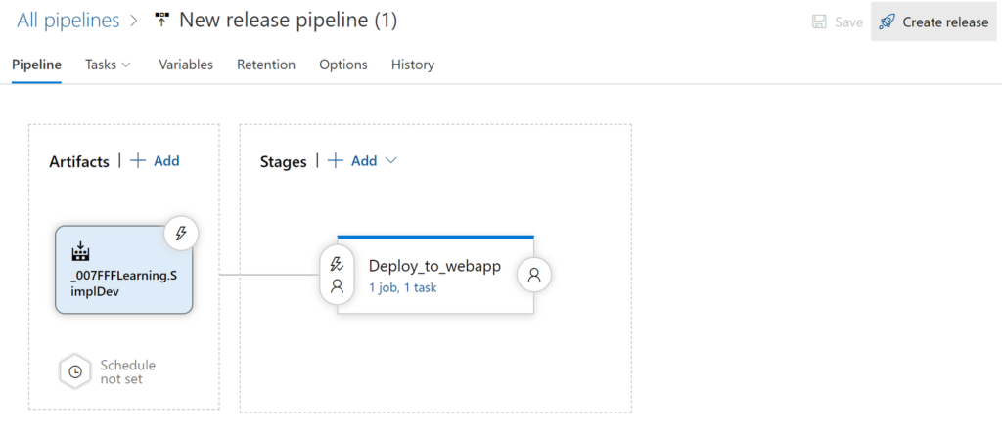New release pipeline overview

2.  You’re not going to do anything fancy so at the **Create a new release** screen, accept the defaults and click on **Create**. You only have a single stage at this time and have a single version of the build artifact to deploy now.

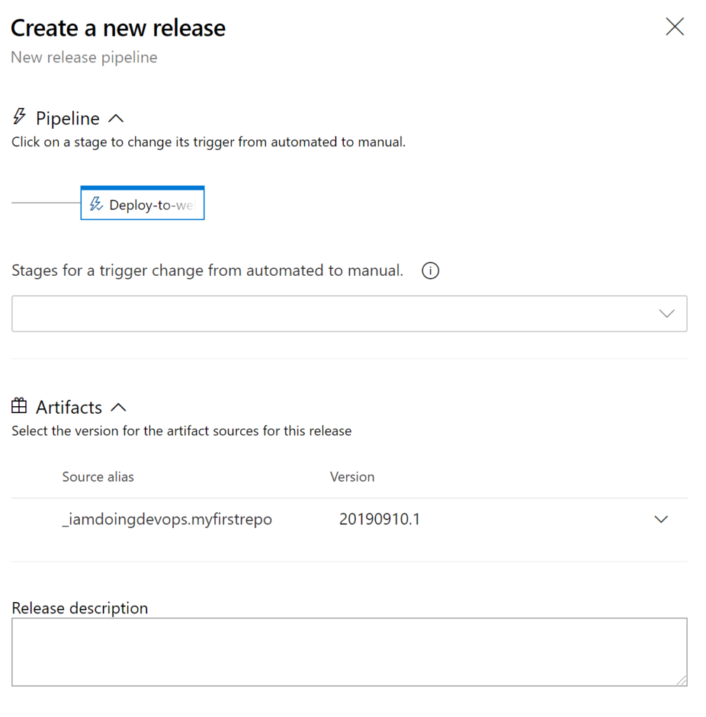Create a new release item

3.  After a few seconds, you will receive a notification (the green bar) that the release has been created as shown below. Now click on **Release-1** which will redirect you to the details of the release process.

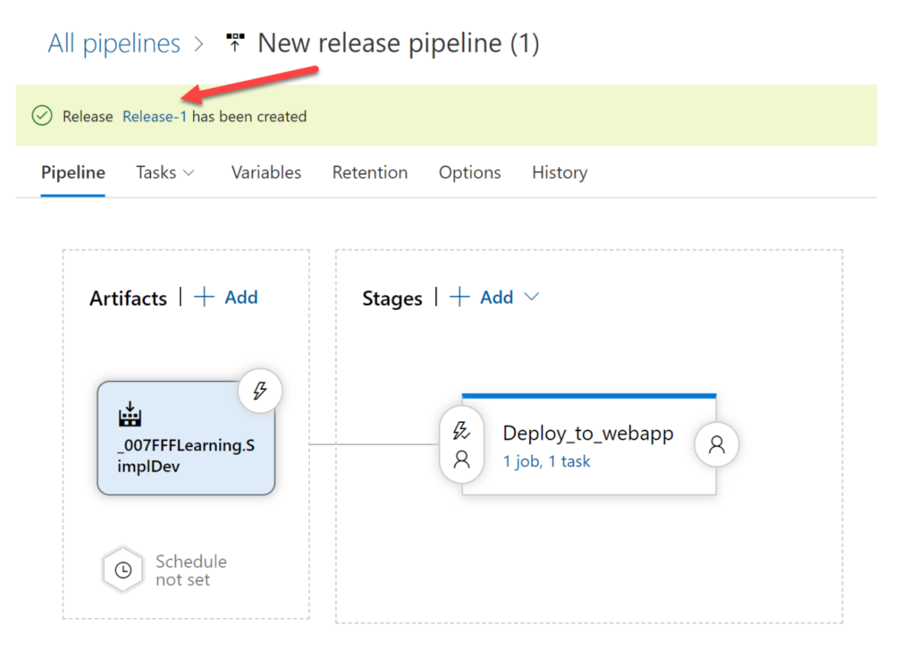Click on Release-1

You have now created a release and it’s ready to be deployed!

## Manually Deploying a Release

A release is a set of instructions to perform on how to deploy a build. You’ve done all of that. Now it’s time to actually run those instructions and deploy code to an environment.

While on the Release-1 release you created earlier:

1. Select the Deploy_to_webapp stage and confirm **Deploy**. When you do so, the status will change to In progress as shown below. At this point, the release is grabbing the source code from the build pipeline executed earlier and pushing it to the Azure WebApp instance.

This step will initiate a job running in the back-end on an [**agent**](https://docs.microsoft.com/en-us/azure/devops/pipelines/agents/agents) copying source code and performing the actual release cycle.

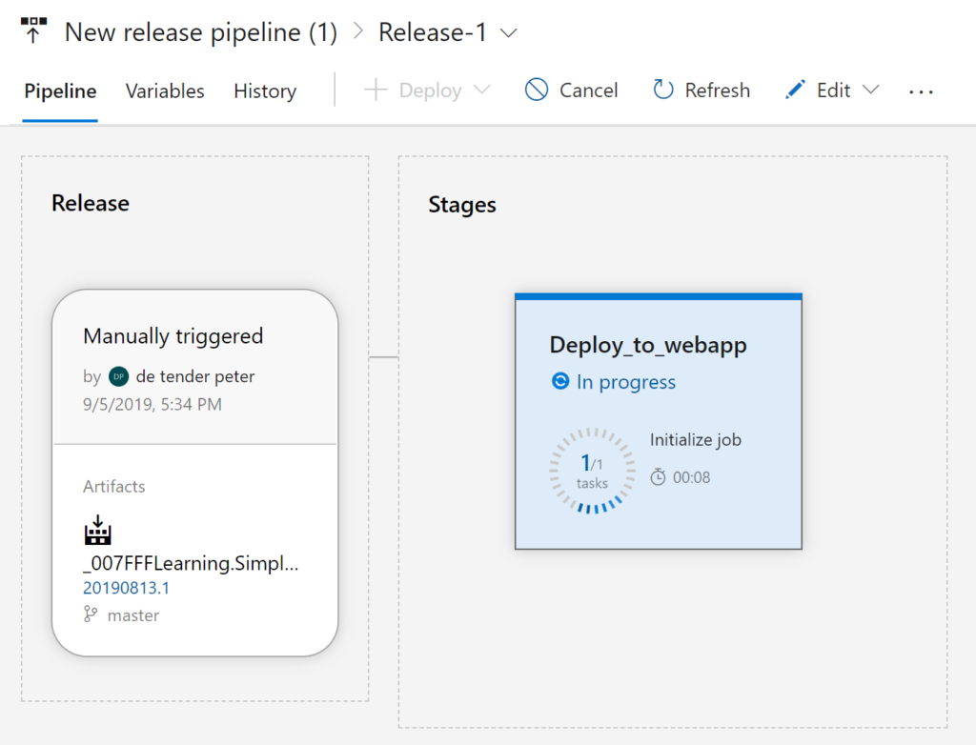Stage in progress

2.  Click on the stage while it’s in progress. You will see any logging information shown in the console output area.

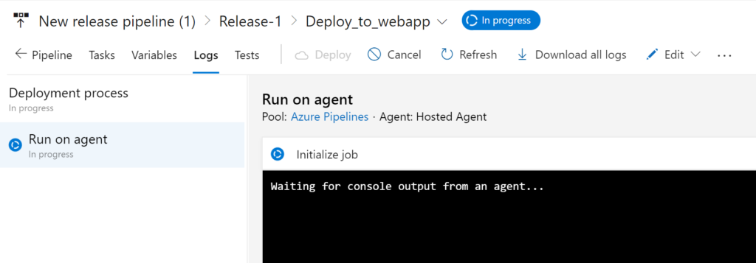Job log showing stage in progress

When complete, the stage should show **Succeeded** as seen below.

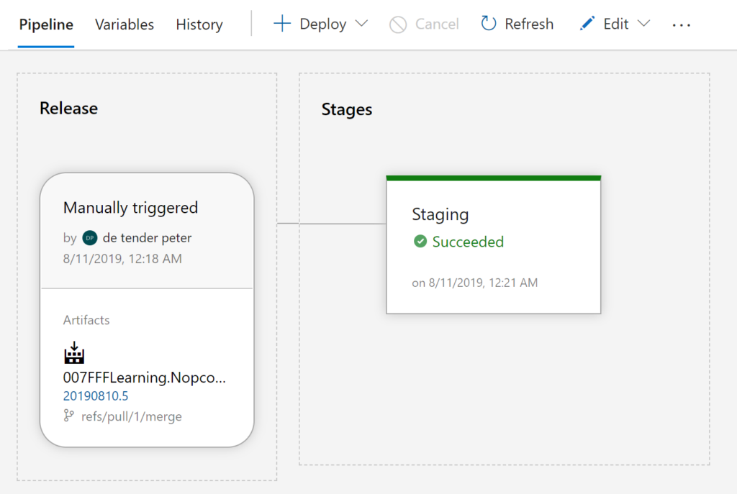Successful stage

If all went well, the release should have finished and you should now have a web app published to an  Azure Web App!

## Inspecting the Deployed Azure WebApp

Now that the entire process is complete, be sure to check out the fruits of your labor.

1. Log into the [**Azure Portal**](https://portal.azure.com/), navigate to the Azure WebApp you selected in the release pipeline as target and copy the URL as shown below.

Finding the Azure App Service URL in the Azure portal

2.  Now paste that URL into a browser by providing the URL of the Azure Web App. Your browser should now load the e-commerce sample application, similar to below home page